[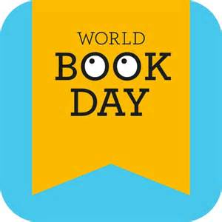](http://www.bing.com/images/search?q=world+book+day&view=detailv2&&id=F2EBEEEF34BFEC48B40A70DE5B1229A512645BD3&selectedIndex=1&ccid=SsAFzSox&simid=608037717838728323&thid=OIP.M4ac005cd2a31af65fcf43afbddccd1b3o0)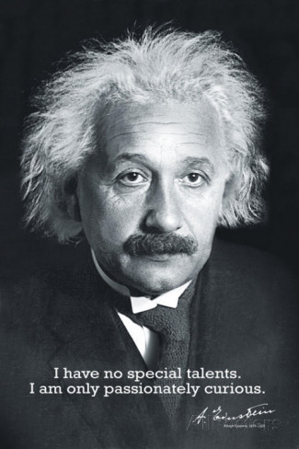**Curiosity Challenge**

English

**This week let’s be curious about:**

Where does your reading take you? 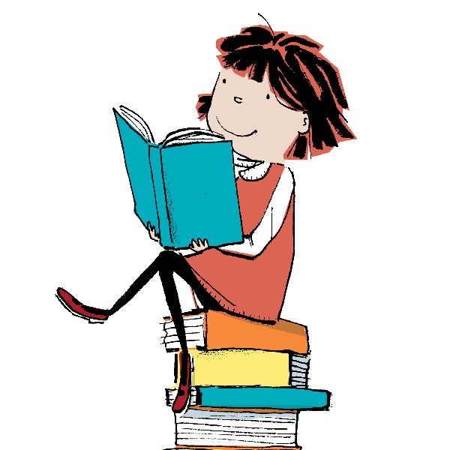

See Miss Britten for more details.

Deadline 9th March