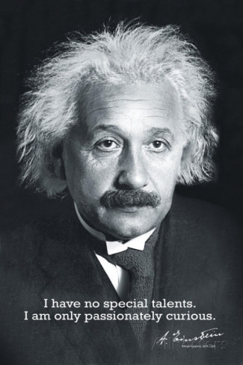**Curiosity Challenge**

Science



**This week let’s be curious about:**

Create a poster on the theme:

“**Space for Science: Science in Spaces”,**

See your science teacher for more details

Deadline 21th March