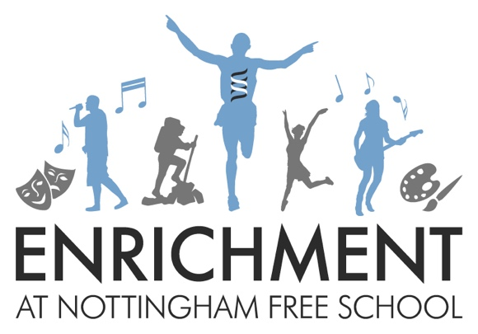

Years 7 and 8

Why?
Why do we have enrichment lessons at Nottingham Free School?

At Nottingham Free School we aim to ensure all of our students achieve a good career through university or equivalent training. The combination of excellent academic qualifications combined with the wider skills developed during enrichment provision gives all of our students the ability to fully develop all of the skills required by employers. The ten key employability skills are shown below.

Employability Skills

1. Self-motivation taking responsibility for developing work readiness

2. Self-assurance having the tools and skills to present themselves to employers

3. Aspiration having high personal goals

4. Informed understanding the opportunities available and making realistic choices

5. Experience having experience of work that is rewarding and fulfilling

6. Achieving qualifications valued by employers

7. Accountability understanding how to take responsibility

8. Resilience understanding employers need for people who can listen and learn

9. Entrepreneurial working creatively to achieve personal and business potential

10. Co-operation developing effective communication and co working skills

Each enrichment lesson you choose will develop at least one of these skills. It is important that you choose lessons that will give you a rounded set of skills. Take time to read through all of the options in the booklet before you are asked to state your preferences. Think about what skills you need to develop as well as activities that you would enjoy. Maybe it’s time to have a new experience and try something completely different, rather than choose something you already have experience of.

Monday

LAMDA

Learn how to perform in small groups to an audience. LAMDA awards qualifications which are recognised by employers and help to build self-confidence as well as have fun!

Students will complete grade 1 and 2 exams if they continue with this course all year.

Be prepared to…
Be prepared to work towards performing at the Christmas concert.

This is useful for…
This will help you to develop your confidence and performance skills. This will also help you develop your public speaking and presentation skills.

Employability skills developed
1. Self-motivation taking responsibility for developing work readiness
2. Self-assurance having the tools and skills to present themselves to employers
3. Aspiration having high personal goals
5. Experience having experience of work that is rewarding and fulfilling
6. Achieving qualifications valued by employers
7. Accountability understanding how to take responsibility
8. Resilience understanding employers need for people who can listen and learn
10. Co-operation developing effective communication and co working skills

Choir

We need you for our school choir!
It doesn’t matter if you think you can’t sing: you just need a willingness to try. We want to create something amazing for the Christmas show.

Be prepared to…
Be prepared to join in, perform and work as a team. You’ll need to learn the words of different songs and how to perform them for an audience.

This is useful for…
Developing musical talent, having fun and developing tools to retain information.

Employability skills developed
1. Self-motivation taking responsibility for developing work readiness
3. Aspiration having high personal goals
5. Experience having experience of work that is rewarding and fulfilling
7. Accountability understanding how to take responsibility
8. Resilience understanding employers need for people who can listen and learn
10. Co-operation developing effective communication and co working skills

Year 8 Football Team

This group will be selected by PE staff. If you are part of the football team, then you can opt for this. Y7 may be added to this after they have started.

Be prepared to…
Work hard, keep up your physical fitness, be part of a team. Compete with students from other schools and represent the Nottingham Free School.

This is useful for…
Developing team tactics and strategies and fixtures with other schools. Learning about overcoming adversity and developing self and team discipline.

Employability skills developed
1. Self-motivation taking responsibility for developing work readiness
3. Aspiration having high personal goals
7. Accountability understanding how to take responsibility
8. Resilience understanding employers need for people who can listen and learn
10. Co-operation developing effective communication and co working skills

Animal Care

If you love animals then this is for you.
This club will look at all sorts of pets and how to care for them using the PDSA resources.
This club will also look into the possibility of adopting a school pet or mascot!

Be prepared to…
Work together and handle animals. Develop an understanding of responsibility for animals in your care.

This is useful for…
Anyone who wants a career with animals, who enjoys Biology or has a responsibility for pets at home.

Employability skills developed
12. Self-assurance having the tools and skills to present themselves to employers
3. Aspiration having high personal goals
4. Informed understanding the opportunities available and making realistic choices
7. Accountability understanding how to take responsibility
8. Resilience understanding employers need for people who can listen and learn
10. Co-operation developing effective communication and co working skills

Girls Football Team

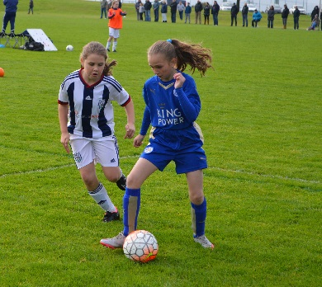

Do you like football? This group will be for girls only and will be coached by Notts County F.C. football coaches.

Be prepared to…
Work hard, keep up your physical fitness, be part of a team. Compete with students from other schools and represent the Nottingham Free School.

This is useful for…
Developing team tactics and strategies and fixtures with other schools. Learning about overcoming adversity and developing self and team discipline.

Employability skills developed
1. Self-motivation taking responsibility for developing work readiness
3. Aspiration having high personal goals
7. Accountability understanding how to take responsibility
8. Resilience understanding employers need for people who can listen and learn
10. Co-operation developing effective communication and co working skills

Charity

This group will look at the purpose of charities and plan their own charity events. We will plan a MacMillan coffee morning and bake sale and a Christmas box appeal. Last year we also lead a charity event to raise money for starfish, a charity who support refugees in Greece.

Be prepared to…
Work as team and give time and make an effort for others. Be organised and plan effectively.

This is useful for…
Raising awareness of different local and world issues and will be an opportunity to think about how to run a business whilst making money for a good cause.

Employability skills developed
1. Self-motivation taking responsibility for developing work readiness
2. Self-assurance having the tools and skills to present themselves to employers
3. Aspiration having high personal goals
4. Informed understanding the opportunities available and making realistic choices
5. Experience having experience of work that is rewarding and fulfilling
7. Accountability understanding how to take responsibility
9. Entrepreneurial working creatively to achieve personal and business potential
10. Co-operation developing effective communication and co working skills

Table Tennis

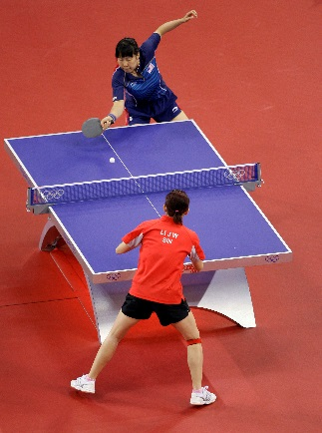

If you want to beat all your friends at break time then come along and learn how to play properly!

Be prepared to…
Keep up your physical fitness and compete with others. Learn to be competitive and demonstrate good sporting behaviour. Develop leadership skills in organising matches and tournaments.

This is useful for…
Developing strategies for playing individually and in pairs. Learning how to win and lose graciously. Learning a game to be able to play in future for recreational purposes.

Employability skills developed
1. Self-motivation taking responsibility for developing work readiness
3. Aspiration having high personal goals
8. Resilience understanding employers need for people who can listen and learn
10. Co-operation developing effective communication and co working skills

Mixed Crafts

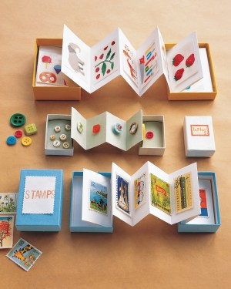
Mixed crafts will include duct tape art, paper craft and origami. You will also have the chance to create and sell your own Christmas cards.

Be prepared to…
Work hard and persevere to create some great pieces of work. Learn to be organised and work carefully and precisely to a high standard.

This is useful for…
Developing your creative side and learning some new creative skills. Developing a sense of achievement. Crafting for some people can be relaxing and a way to express themselves.

Employability skills developed
1. Self-motivation taking responsibility for developing work readiness
2. Self-assurance having the tools and skills to present themselves to employers
3. Aspiration having high personal goals
7. Accountability understanding how to take responsibility
8. Resilience understanding employers need for people who can listen and learn
10. Co-operation developing effective communication and co working skills

Yoga

This class will help you learn some great yoga positions as well as experience yoga relaxation techniques to help you unwind and clear your mind of stress. This class will be delivered by a trained yoga teacher.

Be prepared to…
You need to be reflective and flexible, follow instructions carefully and listen to suggestions about improving your technique.

This is useful for…
Keeping you healthy, both physically and mentally. Learning relaxation techniques that you can return to in later life.

Employability skills developed
1. Self-motivation taking responsibility for developing work readiness
3. Aspiration having high personal goals
8. Resilience understanding employers need for people who can listen and learn
10. Co-operation developing effective communication and co working skills

Wednesday

Football

Do you like football? This group will be for pupils who like football but also for those who want work towards being on the school football team.

Be prepared to…
Work hard, keep up your physical fitness, be part of a team. Be competitive and show good sporting behaviour

This is useful for…
Developing team strategies and fixtures with other schools. Developing friendships and social skills by playing a sport together.

Employability skills developed
1. Self-motivation taking responsibility for developing work readiness
3. Aspiration having high personal goals
7. Accountability understanding how to take responsibility
8. Resilience understanding employers need for people who can listen and learn
10. Co-operation developing effective communication and co working skills

Gym

In this group you get to visit the fantastic Robin Hood Gym and use their facilities and equipment.
You will be coached by an instructor whilst being taught how to use the equipment and perform basic sequences.

Be prepared to…
Work hard and build up your core strength as well as your skills using the equipment. Listen to and act on advice to improve your technique.

This is useful for…
Keeping fit and healthy, improving your self-confidence and sense of well-being.

Employability skills developed
1. Self-motivation taking responsibility for developing work readiness
3. Aspiration having high personal goals
6. Achieving qualifications valued by employers
7. Accountability understanding how to take responsibility
8. Resilience understanding employers need for people who can listen and learn
10. Co-operation developing effective communication and co working skills

Capoeira

This is an amazing opportunity to learn a Brazilian martial art that combines elements of dance, acrobatics and music.
It is known for quick and complex moves, using power, speed, and leverage for a wide variety of kicks, spins, and highly mobile techniques.
Find out more:
http://www.capoeiranottingham.co.uk/
Be prepared to…
Be prepared to work hard at the complex moves and support your fellow students. Perform in front of others.

This is useful for…
Introducing a martial art that you could continue beyond school, keeping you fit and helping you learn about a different culture, language and music at the same time.

Employability skills developed
1. Self-motivation taking responsibility for developing work readiness
2. Self-assurance having the tools and skills to present themselves to employers
3. Aspiration having high personal goals
8. Resilience understanding employers need for people who can listen and learn
10. Co-operation developing effective communication and co working skills

Science/Score

In the first half term you will try out a range of fun experiments that you’ve never tried before.

In the second half term you be taught by a representative from SCoRE. SCoRE (School Collaboration on resource efficiency) is an energy saving programme run by Nottingham City Council working within schools to increase energy efficiency and reduce carbon production. You will have the opportunity to think about what you could do to help.

Be prepared to…
Conduct experiments and work collaboratively with the SCoRE programme to produce ways in which our school community could be more energy efficient.

This is useful for…
Developing your scientific sills and looking after our environment. Improving your grades in Science.

Employability skills developed
2. Self-assurance having the tools and skills to present themselves to employers
4. Informed understanding the opportunities available and making realistic choices
5. Experience having experience of work that is rewarding and fulfilling
7. Accountability understanding how to take responsibility
8. Resilience understanding employers need for people who can listen and learn
10. Co-operation developing effective communication and co working skills

Orchestra

This is a chance to play your instruments with others. You will learn to work as a team to perform musical pieces from different musical eras and genres.

You do not have to have a particular grade but you do need to be able to play an instrument.

Be prepared to…
Play an instrument with others and perform in front of others. Work hard to deliver a performance to a high standard on behalf of the school.

This is useful for…
Students who want to develop their musical performance skills, who want to pursue music GCSE or who may be considering a career in the music industry.

Employability skills developed
1. Self-motivation taking responsibility for developing work readiness
3. Aspiration having high personal goals
5. Experience having experience of work that is rewarding and fulfilling
7. Accountability understanding how to take responsibility
8. Resilience understanding employers need for people who can listen and learn
10. Co-operation developing effective communication and co working skills

Creative Arts

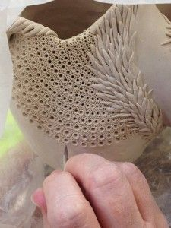
This is an opportunity to get creative. Learn a range of techniques and create your own inspired work using a range of materials such as wire, air dry clay, paint, printing, oil pastels and much more! Over the term you'll get a chance to expand your skills and techniques and learn about new artists to help inspire your work. This will be perfect for you if you are enthusiastic about art and love being creative.
Be prepared to…
Learn about different artists and get inspired to develop your own ideas and creations.

This is useful for…
Exploring your creative side and developing and understanding of the art world. Improving your grades in art and creative subjects. Developing patience and perseverance with your work as it develops.

Employability skills developed
3. Aspiration having high personal goals
7. Accountability understanding how to take responsibility
8. Resilience understanding employers need for people who can listen and learn
10. Co-operation developing effective communication and co working skills

Book Club

Do you ever get to the end of the day and just want to sit and relax with a good book?
This club will give you the space and time to read great literature and explore different narratives and genres. You will also review books and look at book cover design.

Be prepared to…
Spend time reading and sharing your opinions and ideas about books, promote reading amongst your peers and explore different types of writing.

This is useful for…
Increasing your reading age, developing your literacy and improving not just your English grades but grades in all subjects. Increasing your general knowledge of the world through reading.

Employability skills developed
1. Self-motivation taking responsibility for developing work readiness
3. Aspiration having high personal goals
5. Experience having experience of work that is rewarding and fulfilling
8. Resilience understanding employers need for people who can listen and learn
10. Co-operation developing effective communication and co working skills

Drama/NAE

In this group you will develop your acting and performing skills.

In the first half term, we hope to work with professional actors from the ZeroPlus theatre company who are performing the play “My Grandad and I” in Nottingham.

In the second half term, you will work towards a Christmas performance.

Be prepared to…
Act in front of an audience, practice and learn drama skills such as performance, improvisation and voice projection.

This is useful for…
Developing self confidence in public speaking and presentations. Exploring your creativity and learning about scripts as a form of literature. Learning how to retain information by finding ways to memorise lines and directions.

Employability skills developed
1. Self-motivation taking responsibility for developing work readiness
2. Self-assurance having the tools and skills to present themselves to employers
3. Aspiration having high personal goals
5. Experience having experience of work that is rewarding and fulfilling
7. Accountability understanding how to take responsibility
8. Resilience understanding employers need for people who can listen and learn
10. Co-operation developing effective communication and co working skills

NAME: TUTOR SET:
PLEASE HAND THIS COPY IN TO RECEPTION
Y7 and Y8 Enrichment activities option form
Please rank your preferences in order with 1 being your first choice.
Please be aware that the activities may alter slightly depending on demand and popular choices might be repeated in the second term if demand is high. Not everyone can be allocated their first choice on Monday and Wednesday but we will do our best.
Do this for Monday and Wednesday
Monday
Activity | Rank order (1 = first choice)
LAMDA
Choir
Y8 Football team
Animal Care
Girls Football
Charity
Table Tennis
Mixed Crafts
Yoga

Wednesday
Activity | Rank order (1 = first choice)
Football
Gym
Capoeira
Science
Orchestra
Art
Book Club
Drama

