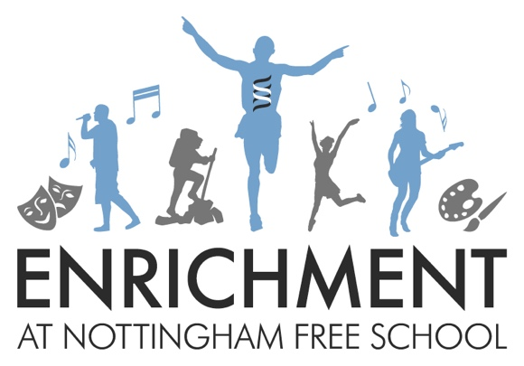

Years 7 and 8
Spring Term
Why?
Why do we have enrichment lessons at Nottingham Free School?

At Nottingham Free School we aim to ensure all of our students achieve a good career through university or equivalent training. The combination of excellent academic qualifications combined with the wider skills developed during enrichment provision gives all of our students the ability to fully develop all of the skills required by employers. The ten key employability skills are shown below.

Employability Skills

1. Self-motivation taking responsibility for developing work readiness

2. Self-assurance having the tools and skills to present themselves to employers

3. Aspiration having high personal goals

4. Informed understanding the opportunities available and making realistic choices

5. Experience having experience of work that is rewarding and fulfilling

6. Achieving qualifications valued by employers

7. Accountability understanding how to take responsibility

8. Resilience understanding employers need for people who can listen and learn

9. Entrepreneurial working creatively to achieve personal and business potential

10. Co-operation developing effective communication and co working skills

Each enrichment lesson you choose will develop at least one of these skills. It is important that you choose lessons that will give you a rounded set of skills. Take time to read through all of the options in the booklet before you are asked to state your preferences. Think about what skills you need to develop as well as activities that you would enjoy. Maybe it’s time to have a new experience and try something completely different, rather than choose something you already have experience of.

Monday

LAMDA

Learn how to perform in small groups to an audience. LAMDA awards qualifications which are recognised by employers and help to build self-confidence as well as have fun!

Students will complete grade 1 and 2 exams at Easter.

YOU HAVE TO CHOOSE THIS AS YOUR FIRST CHOICE IF YOU ARE ALREADY DOING THIS.

Be prepared to…
Be prepared to work towards performing in school and for your exam.

This is useful for…
This will help you to develop your confidence and performance skills. This will also help you develop your public speaking and presentation skills.

Employability skills developed
1. Self-motivation taking responsibility for developing work readiness
2. Self-assurance having the tools and skills to present themselves to employers
3. Aspiration having high personal goals
5. Experience having experience of work that is rewarding and fulfilling
6. Achieving qualifications valued by employers
7. Accountability understanding how to take responsibility
8. Resilience understanding employers need for people who can listen and learn
10. Co-operation developing effective communication and co working skills

Choir

We need you for our school choir!
It doesn’t matter if you think you can’t sing: you just need a willingness to try. We want to create something amazing.

Be prepared to…
Be prepared to join in, perform and work as a team. You’ll need to learn the words of different songs and how to perform them for an audience.

This is useful for…
Developing musical talent, having fun and developing tools to retain information.

Employability skills developed
1. Self-motivation taking responsibility for developing work readiness
3. Aspiration having high personal goals
5. Experience having experience of work that is rewarding and fulfilling
7. Accountability understanding how to take responsibility
8. Resilience understanding employers need for people who can listen and learn
10. Co-operation developing effective communication and co working skills

Drama

Do you want to develop your acting skills? Do you want to take part in fun scripted sketches and have the opportunity to devise your own pieces of theatre whilst learning about how to use voice, movement and facial expression (amongst many other skills) effectively in order to create a character? Then Nottingham Free School Drama Club is for you! Come along and take part in exciting performance workshops that will leave you feeling energised and inspired. Unleash your creativity and have the time of your life whilst learning many valuable new skills.

Be prepared to…
Act in front of an audience, practice and learn drama skills such as performance, improvisation and voice projection. Take part in workshops that explore the use of mime, physical theatre, chorus and ensemble work. Perform some Shakespeare (yes, that’s right…Shakespeare!) Participate in exercises that improve focus, concentration and listening skills as well as collaborative working. Learn short scripted pieces for performance.
This is useful for…
Developing self confidence in public speaking and presentations. Exploring your creativity and learning about scripts as a form of literature. Learning how to retain information by finding ways to memorise lines and directions.
Employability skills developed
1. Self-motivation taking responsibility for developing work readiness
2. Self-assurance having the tools and skills to present themselves to employers
3. Aspiration having high personal goals
5. Experience having experience of work that is rewarding and fulfilling
7. Accountability understanding how to take responsibility
8. Resilience understanding employers need for people who can listen and learn
10. Co-operation developing effective communication and co working skills

Year 7/8 Boys Football
Come and play Football against the best Footballers in your year group. Train for fixtures to represent the school against other schools!

Be prepared to…
Work hard, keep up your physical fitness, be part of a team. Compete with students from other schools and represent the Nottingham Free School.

This is useful for…
Developing team tactics and strategies and fixtures with other schools. Learning about overcoming adversity and developing self and team discipline.

Employability skills developed
1. Self-motivation taking responsibility for developing work readiness
3. Aspiration having high personal goals
7. Accountability understanding how to take responsibility
8. Resilience understanding employers need for people who can listen and learn
10. Co-operation developing effective communication and co working skills

Changing Rooms

This enrichment club will help you to learn some practical skills which you will use again and again. We will practise the basic skills of design and DIY by planning, decorating and furnishing a room in the school. This will help you to develop useful life skills, as well as providing a nice, welcoming environment for students to use. You will be involved at every stage of the process, from sketching out initial design ideas, to choosing and buying the furniture, and then building it!

Be prepared to…
Work together and handle tools. Develop an understanding of how to plan for a project.

This is useful for…
Anyone who wants a career with DIY or has a flare for interior design.

Employability skills developed
1. Self-motivation taking responsibility for developing work readiness
2. Self-assurance having the tools and skills to present themselves to employers
4. Informed understanding the opportunities available and making realistic choices
5. Experience having experience of work that is rewarding and fulfilling
8. Resilience understanding employers need for people who can listen and learn
9. Entrepreneurial working creatively to achieve personal and business potential
10. Co-operation developing effective communication and co working skills

Girls Football

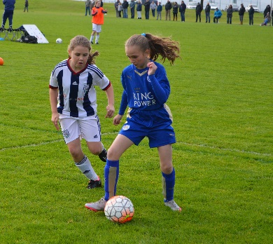

Do you like football? This group will be for girls only and will be coached by Notts County F.C. football coaches.

Be prepared to…
Work hard, keep up your physical fitness, be part of a team. Compete with students from other schools and represent the Nottingham Free School.

This is useful for…
Developing team tactics and strategies and fixtures with other schools. Learning about overcoming adversity and developing self and team discipline.

Employability skills developed
1. Self-motivation taking responsibility for developing work readiness
3. Aspiration having high personal goals
7. Accountability understanding how to take responsibility
8. Resilience understanding employers need for people who can listen and learn
10. Co-operation developing effective communication and co working skills

Problem Solving

Learn to develop teamwork and communication skills through mathematical problem solving.

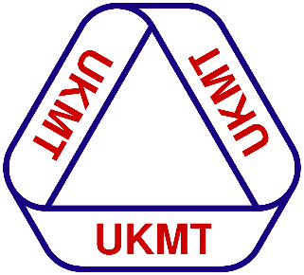
Run fortnightly whole school maths 'hot board' challenges.

Compete to be part of the schools team to go to a regional UKMT team mathematics competition.

Be prepared to…
Work as team and give time and make an effort for others. Be organised and plan effectively.

This is useful for…
Developing skills for problem solving and critical thinking.

Employability skills developed
1. Self-motivation taking responsibility for developing work readiness
2. Self-assurance having the tools and skills to present themselves to employers
3. Aspiration having high personal goals
5. Experience having experience of work that is rewarding and fulfilling
8. Resilience understanding employers need for people who can listen and learn
10. Co-operation developing effective communication and co working skills

Table Tennis

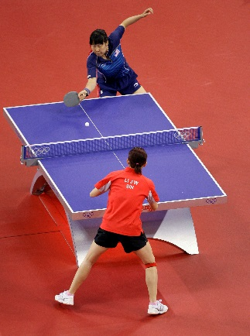

If you want to beat all your friends at break time then come along and learn how to play properly!

Be prepared to…
Keep up your physical fitness and compete with others. Learn to be competitive and demonstrate good sporting behaviour. Develop leadership skills in organising matches and tournaments.

This is useful for…
Developing strategies for playing individually and in pairs. Learning how to win and lose graciously. Learning a game to be able to play in future for recreational purposes.

Employability skills developed
1. Self-motivation taking responsibility for developing work readiness
3. Aspiration having high personal goals
8. Resilience understanding employers need for people who can listen and learn
10. Co-operation developing effective communication and co working skills

Book Club

Do you ever get to the end of the day and just want to sit and relax with a good book?
This club will give you the space and time to read great literature and explore different narratives and genres. You will also review books and look at book cover design.

Be prepared to…
Spend time reading and sharing your opinions and ideas about books, promote reading amongst your peers and explore different types of writing.

This is useful for…
Increasing your reading age, developing your literacy and improving not just your English grades but grades in all subjects. Increasing your general knowledge of the world through reading.

Employability skills developed
1. Self-motivation taking responsibility for developing work readiness
3. Aspiration having high personal goals
5. Experience having experience of work that is rewarding and fulfilling
8. Resilience understanding employers need for people who can listen and learn
10. Co-operation developing effective communication and co working skills

Wednesday

Multi-Sports

Do you think you don’t have enough time to play team sports? Would you like to extend your skills and have a chance to represent the school in different team sports? Then come along and practise a range of sports!

This is for boys and girls.

Be prepared to…
Work hard, keep up your physical fitness, be part of a team. Be competitive and show good sporting behaviour

This is useful for…
Developing team strategies and fixtures with other schools. Developing friendships and social skills by playing a sport together.

Employability skills developed
1. Self-motivation taking responsibility for developing work readiness
3. Aspiration having high personal goals
7. Accountability understanding how to take responsibility
8. Resilience understanding employers need for people who can listen and learn
10. Co-operation developing effective communication and co working skills

Gym

In this group you get to visit the fantastic Robin Hood Gym and use their facilities and equipment.
You will be coached by an instructor whilst being taught how to use the equipment and perform basic sequences.

PLEASE DO NOT PUT THIS DOWN FOR YOUR FIRST CHOICE IF YOU HAVE ALREADY DONE IT.

Be prepared to…
Work hard and build up your core strength as well as your skills using the equipment. Listen to and act on advice to improve your technique.

This is useful for…
Keeping fit and healthy, improving your self-confidence and sense of well-being.

Employability skills developed
1. Self-motivation taking responsibility for developing work readiness
3. Aspiration having high personal goals
6. Achieving qualifications valued by employers
7. Accountability understanding how to take responsibility
8. Resilience understanding employers need for people who can listen and learn
10. Co-operation developing effective communication and co working skills

Capoeira

This is an amazing opportunity to learn a Brazilian martial art that combines elements of dance, acrobatics and music.
It is known for quick and complex moves, using power, speed, and leverage for a wide variety of kicks, spins, and highly mobile techniques.
Find out more:
http://www.capoeiranottingham.co.uk/
Be prepared to…
Be prepared to work hard at the complex moves and support your fellow students. Perform in front of others.

This is useful for…
Introducing a martial art that you could continue beyond school, keeping you fit and helping you learn about a different culture, language and music at the same time.

Employability skills developed
1. Self-motivation taking responsibility for developing work readiness
2. Self-assurance having the tools and skills to present themselves to employers
3. Aspiration having high personal goals
8. Resilience understanding employers need for people who can listen and learn
10. Co-operation developing effective communication and co working skills

Orchestra

This is a chance to play your instruments with others. You will learn to work as a team to perform musical pieces from different musical eras and genres.

You do not have to have a particular grade but you do need to be able to play an instrument.

Be prepared to…
Play an instrument with others and perform in front of others. Work hard to deliver a performance to a high standard on behalf of the school.

This is useful for…
Students who want to develop their musical performance skills, who want to pursue music GCSE or who may be considering a career in the music industry.

Employability skills developed
1. Self-motivation taking responsibility for developing work readiness
3. Aspiration having high personal goals
5. Experience having experience of work that is rewarding and fulfilling
7. Accountability understanding how to take responsibility
8. Resilience understanding employers need for people who can listen and learn
10. Co-operation developing effective communication and co working skills

Dance

This is a chance to explore different dance styles and express your creativity through Dance.

You do not need to have any Dance experience to be a part of this Enrichment club. Everyone is welcome!

Be prepared to…
Work hard and persevere to create some great pieces of work. Learn to be organised and work carefully and precisely to a high standard.

This is useful for…
Developing your creative side and learning some dance skills. Develop a sense of achievement creating pieces for performance.

Employability skills developed (delete as applicable)
1. Self-motivation taking responsibility for developing work readiness
3. Aspiration having high personal goals
5. Experience having experience of work that is rewarding and fulfilling
8. Resilience understanding employers need for people who can listen and learn
10. Co-operation developing effective communication and co working skills

Creative Arts

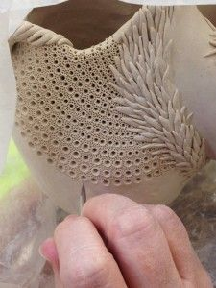
This is an opportunity to get creative. Learn a range of techniques and create your own inspired work using a range of materials such as wire, air dry clay, paint, printing, oil pastels and much more! Over the term you'll get a chance to expand your skills and techniques and learn about new artists to help inspire your work. This will be perfect for you if you are enthusiastic about art and love being creative.

YOU CANNOT TAKE THIS IF YOU HAVE ALREADY TAKEN IT
Be prepared to…
Learn about different artists and get inspired to develop your own ideas and creations.

This is useful for…
Exploring your creative side and developing and understanding of the art world. Improving your grades in art and creative subjects. Developing patience and perseverance with your work as it develops.

Employability skills developed
3. Aspiration having high personal goals
7. Accountability understanding how to take responsibility
8. Resilience understanding employers need for people who can listen and learn
10. Co-operation developing effective communication and co working skills

Boy Power

It is said emotional intelligence is crucial for academic intelligence, success in life, being a great leader, having good social skills, self management and motivation.

In Boy Power you will GAIN:
- An understanding about our ancestral CAVEMAN’s brains and why anger, stress and anxiety were important, and why we still have those ‘high’ emotional states today
- An understanding on how to control of your anger/fear/anxiety/stress
- Knowledge of how to achieve to the best of your ability
- How to become successful in life
- More confidence/self belief and raised self esteem
- Skills to create positive relationships and deal with confrontations effectively
- Skills to be a great leader/role model
- Emotional Intelligence Gaining self awareness, managing emotions, effective communication

Come and join us to take part in challenges, games and much more to help you discover your REAL POTENTIAL!
Be prepared to…
Be challenged, be inspired and be empowered to be the best you can be!

This is useful for…
Realising your own potential, so you can achieve at your highest level, using these crucial ‘life’ skills both at school and in the future.
Employability skills developed (delete as applicable)
1. Self-motivation taking responsibility for developing work readiness
2. Self-assurance having the tools and skills to present themselves to employers
3. Aspiration having high personal goals
5. Experience having experience of work that is rewarding and fulfilling
7. Accountability understanding how to take responsibility
8. Resilience understanding employers need for people who can listen and learn
10. Co-operation developing effective communication and co working skills

Baking

Fan of the Bake Off? Love to get crafty with cookies? Are you excited by icing? If so, this is the group for you. Throughout the 12 week course we will focus on baking and decorating beautiful sweet products. You will need to be a patient person as some of the activities will test your perseverance and resilience skills.

If the thought of being creative leaves you with a sense of dread, then maybe give this a miss.

There will be a cost of £10 to cover ingredients for this course.

Be prepared to…
Wash up at the end of the session!
Be organised with ingredients
Bring tubs to take your baking home in
Have a load of fun and learn new skills

This is useful for…
Developing your creative side and learning some cake decorating skills. Develop a sense of achievement.

Employability skills developed (delete as applicable)
1. Self-motivation taking responsibility for developing work readiness
3. Aspiration having high personal goals
5. Experience having experience of work that is rewarding and fulfilling
7. Accountability understanding how to take responsibility
8. Resilience understanding employers need for people who can listen and learn
10. Co-operation developing effective communication and co working skills

NAME: TUTOR SET:
PLEASE HAND THIS COPY IN TO RECEPTION
Y7 and Y8 Enrichment activities option form
Please rank your preferences in order with 1 being your first choice.
Please be aware that the activities may alter slightly depending on demand and popular choices might be repeated in the second term if demand is high. Not everyone can be allocated their first choice on Monday and Wednesday but we will do our best.
Do this for Monday and Wednesday
Monday
Activity | Rank order (1 = first choice)
LAMDA
Choir
Drama
Y7/8 Boys Football
Changing Rooms
Girls Football
Problem Solving
Table Tennis
Book Club

Wednesday
Activity | Rank order (1 = first choice)
Multi-sports (boys and girls)
Gym
Capoeira
Orchestra
Dance
Creative Arts
Boy Power
Baking

