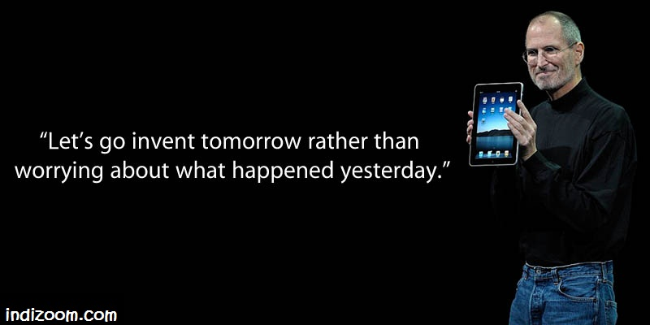**Curiosity Challenge: this week let’s be curious about:**

**Computer Studies**

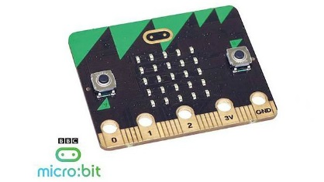

**Hand it in to Mr Takpaul By 6th of May**

**Best Entry will win a BBC Mirco-Bit**

Computers and ICT are everywhere and have impacted society. Your Task is to create a A-Z of careers that use some form of ICT or Computing. You will need to write a short description of how it is used in that particular career.