**Curiosity Challenge**

Drama 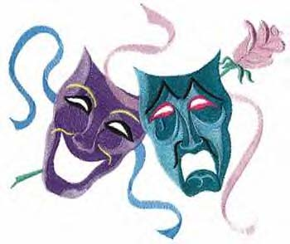

**This week let’s be curious about:**

**Create a monologue/duologue**

You will be given a monologue or duologue on request. You can then record your monologue or duologue on your ipad and send to Miss Nicholls.