**Curiosity Challenge**

Maths[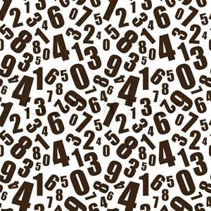](http://www.bing.com/images/search?q=numbers&view=detailv2&&id=A1DA62A4AE6A464000C827F131C96242D9418EB8&selectedIndex=0&ccid=6SWHz16V&simid=608054214967821069&thid=OIP.Me92587cf5e9559dd40fefdbd59e04a05H0)

**This week let’s be curious about:**

**Were numbers discovered or invented?**

Write a short essay showing your thoughts. You can use research to help prove your argument.

Entries to Mrs Farnie or Mr Trasler-Mee by 6th July