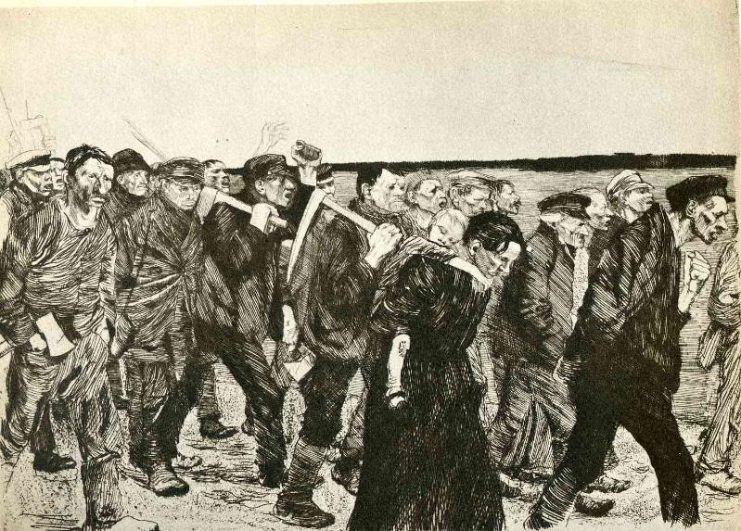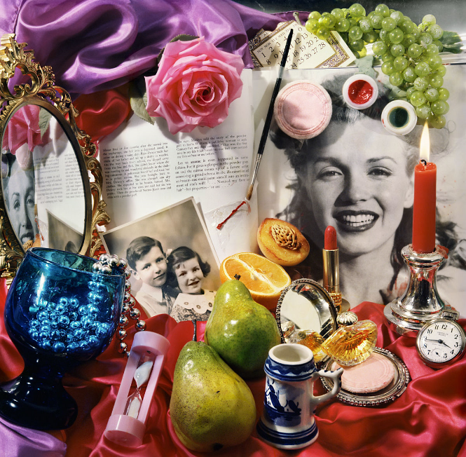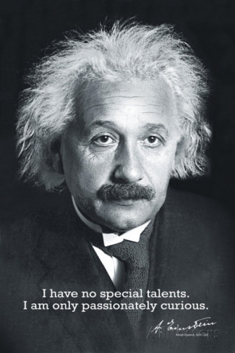**Curiosity Challenge**

Art

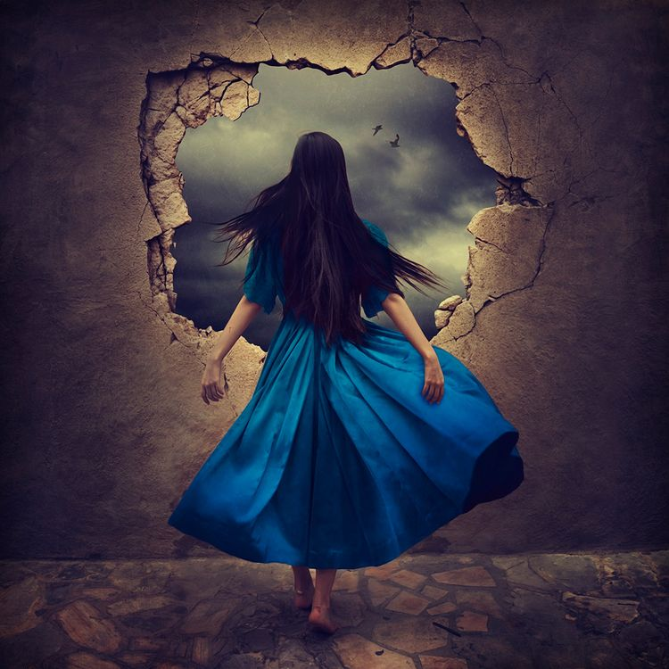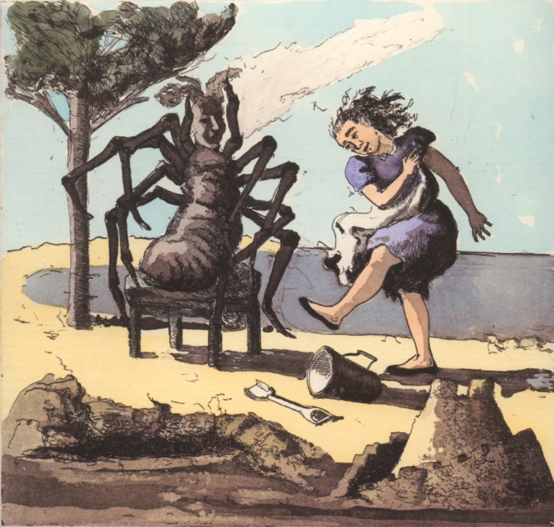**This week let’s be curious about:**

**‘Every picture tells a story’- a lot of artists use narratives in their work (meaning a piece of work can hold a hidden story).**

**Using your choice of materials or technique create a piece that tells a story.**

**It could be:**

⇒ **A fairy tale or a children’s story.**

⇒ **A personal story or memory.**

⇒ **Or could depict a historical event that you feel is important.**

**Your piece must be no bigger than A3 and no felt tip pens!**

**All pieces need to be handed in to Mrs Wilken by the 29th January.**