A-Level Spanish A level Guide
How Spanish will be taught:
- 5 lessons per week
- 1 speaking focused lesson
- 2 theme/grammar based lessons
- 2 literature/film based lessons
- Covering all 4 skills

Working expectations:
- Attend all lessons
- Contribute ideas to lessons
- Don’t be afraid to make mistakes
- Complete organised and neat notes
- Keep an organised folder with work filed in sections
- Complete all tasks to the best of your ability
- Proof read and check your work before handing in
- Seek guidance and help when required
- Take ownership of your work and achievement
- Watch Spanish TV programmes, films, series & read Spanish news
- Do independent grammar practice

What 100% effort in this subject looks like:
- Completing all work to the best of your ability and checking it carefully before submitting
- Asking for additional work where required
- Taking an active interest in and reading Spanish news, as well as watching news videos and doing independent tasks without being directed to
- Carrying out independent research on an area of your own interest based on Spain or Latin America
- Carrying out daily learning and practice of Quizlet vocabulary and grammar

Folder Policy:
Your folder should have:
-Contents page
-Sections including the different themes, grammar, literary text, film, assessments, vocabulary tests
-Sample answers
-AQA Spanish mark scheme
-Revision

What marking looks like:
- Class notes are not marked
- Vocabulary and grammar tests are self-marked with teacher feedback
- Assessments are self-marked with teacher feedback
- Summaries and longer written work is marked by teachers with GPA feedback
- Verbal feedback given in all lessons

What homework looks like:
On a weekly basis, you will receive:
- 1 speaking exam practice card and speaking questions to write answers to
- Some reading, writing, listening & grammar activities based on a theme
- Vocabulary Quizlet to learn
- Some film or literary text based writing or research
- Expectation that you read and watch some Spanish news
Specification at a glance:
You study a range of topics within the following themes relating to Spain and Latin America:
-Social issues and trends
-Political and artistic culture
You also read the literary text ‘Un requiem por un campesino español’ novel by Ramon J Sender and you study the film ‘Volver’ directed by Pedro Almodóvar.
You also carry out an independent research project on any area of your own interest related to Hispanic society and culture, which is assessed in the speaking assessment.
Link to the full specification:
https://filestore.aqa.org.uk/resources/spanish/specifications/AQA-7692-SP-2016.PDF
Assessments:
- Listening, reading and writing exam – 2 hours 30 minutes – 50% of overall grade – Hispanic society & grammar
- Writing exam – 2 hours – 20% of overall grade – 1 essay question in Spanish based on the film and 1 based on the book
- Speaking exam – 21-23 minutes – 30% of overall grade – independent research project & one theme
Summer preparation tasks
The purpose of giving you summer bridging tasks is:
- To provide a bridge from level 2 to level 3 study, and lead into the early stages of the course.
- To engage you in independent learning which is required at level 3.
- To encourage you to develop your work ethic and commitment to study.
- To measure your suitability for the course and assess your initial levels of achievement.
Please complete all of the following tasks. They can be done in any order:

Use this link to memorise some important A Level vocabulary. Create a free account. Keep a note of the sections you have completed. https://www.memrise.com/course/395583/a-level-spanish-vocabulary-2/

Use this link to memorise some important A Level VERBS. Keep a note of the sections you have completed. https://www.memrise.com/course/798880/a-level-spanish-verbs/

Practise these complex structures on Quizlet, then have a go at the test (appendix 1) https://quizlet.com/_7gvurv?x=1jqt&i=191fbz

Create a free account on this amazing website for verb and grammar practice and work your way through some activities. Take screenshot or make a note of your scores. https://conjuguemos.com/auth/create_start

Read the background notes & make your own spider diagram/flash cards about the Volver film (appendix 2)

Have a go at the Carmen Herrero ‘Volver’ film work here file:///S:/CDMProfile/Downloads/CarmenHerrero_Volver.pdf

Complete the activities on Equal Rights (appendix 3)

Watch some Spanish news videos. Make a note of which videos you watch and summaries of what they were about in English: https://www.youtube.com/channel/UCRwA1NUcUnwsly35ikGhp0A or https://www.ihes.com/bcn/spanish/media.html
Watch this great Storyville documentary about Franco’s dictatorship: https://www.bbc.co.uk/iplayer/episode/m000bynq/storyville-facing-francos-crimes-the-silence-of-others
Read and make notes about the Spanish civil war: https://www.britannica.com/event/Spanish-Civil-War
Further optional tasks & helpful links:
Watch the ‘Volver’ film by Pedro Almodóvar (this is the one we study and you will be assessed on)

Buy the novel ‘Un requiem por un campesino español’ and start reading it, making notes as you go

Watch the Spanish news: www.youtube.com/user/BBCMundo or www.rtve.es
Watch some short videos about important themes in Spanish: www.youtube.com/playlist?list=PLLhUyPZ7578eOhaDzuQaUohvgFzplupf-
Read the Spanish news: www.bbcmundo.es or www.elpais.es
Watch Spanish films on Netflix: La llamada, Perdiendo el norte, Ocho apellidos vascos, Ocho apellidos catalanes, Palmeras en la nieve, Toc Toc, Campeones, Coco, El libro de la vida, A pesar de todo, Contratiempo
Watch Spanish series on Netflix: Élite (current 6th form students love this), La casa de papel, Las chicas del cable, El vecino, La catedral del mar, Paquita salas, Vivir sin permiso
Read and do your own research about the Incas, the Aztecs & the Moors
Please bring your work with you to your first lesson. Look forward to seeing you then

APPENDIX 1 – complex structures test
Until I have / there is / it is / I do | H_______________ q_____ t______________ / h__________ / s_____ / h_________
A lot remains to be done | Q_____________ m_________________ p______ h____________________
It’s worth the effort | N___ v_____________ l___ p_____________
I wish I could conclude (saying that) | O___________________ p________________ c_______________(d__________________ q____)
What’s important / what worries me is | L___ q______ i________________ / m___ p___________________ e____
It / they have revolutionised our way of living | H______ r_____________________________ n_______________ f___________ d___ v_____________
Is seen / is carried out /is celebrated / is organised | S___ v_____ / s___ r______________ / s___ c______________ / s___ o__________________
No only….but also | N___ s___________ …. s_________ t___________________
There is no doubt that | N_____ c_________ n________________ d_________ d__ q______ / s______ d__________ a_____________________
Becomes / became / was becoming | S__ h________ / s__ h___________ / s__ h_______________
To not agree with those who say that | N___ e______________ d__ a____________ c____ l___ q____ d__________ q____
The figure/number continues to increase / decrease | L___ c__________/t________ s____________ a______________________ / b____________________ / d_____________________________
More and more / less and less | C_________ v_____ m______ / m_____________
Neither….nor….Either | N____..... ni……t______________________
According to | S__________________
For ___ years | D____________ h_________ d______ a______ + p_______________ tense
____ years ago | H___________ s__________ m____________ + p_________________ tense
It was a big step forwards / backwards | F______ u___ g_________ p________ a____________________ / a__________
From my point of view | ___ m__ m_______ d___ v_____ / d__________ q_______ / ___ m___ p_________________
Whilst / although / however / thus / even so / even | M______________ q____ /a_____________ / s____ e______________ / a_______ / a_____ a________ / i_____________________
Like | A___ i_____________ q______
Both | A______________
For this reason | P____ e________ m______________ / p_____ e________ r________________
I am offended when | M___ l____________ ___ o________________ c________________
In a well-intended way | D___ m_________ b_________________________________
How much… | L___ m_____________ q_____
As if it were / they were | C____________ s___ f_______________
However much effort one makes | P_______ m___________________ q______ s___ e_________________________
It has / they have become increasingly / less & less | S____ h______ h________________ c_________ v________ m______ / m________
It has / they have already become | S____ h____ c______________________ y___ e___
As well as | A______________________ / a______ c___________
The advantages outweigh the risks | L_____ v_______________________ s___________________ l_____ r_____________
I don’t want that / it surprises me that is is /there is / it has / it does/makes | N___ q____________ q___ / m___ s_________________ q____ s______ / h_________ / t_______________ / h___________
The percentage which reaches ___% in the case of… | P___________________________ q______ s___ e_____________ a___ _____% e____ e_____ c______________ d___
According to what the report deduces | S________________ s___ d__________________ d____ i___________________
In this way | D____ e_________ m__________________ / e___ e_________ s_________________
Is / are the least worrying | E___ / s______ c________________ m___________ p___________________________
It’s not surprising that they do / use / are / have… | N__ e___ d___ e__________________ q____ h____________/u__________/s__________/t__________________
Other worrying data focuses on… | O_________ d________ p_________________ s___ c____________ e__ q____
They have taken advantage of the fact that……has been growing quickly | S___ h____ a____________________ d___ q______.......h_________ s__________ c_________________________ r___________________________
Whose / his/hers/theirs/ mine | C_______________ / s_______________ / m__________
It has been growing | H____ i_____ c__________________________
What/which | L____ / l____ / l_______ / l_______ q_______
What we do know is that | L___ q_____ s___ s____________ e___ q________
It/are nowadays linked to | E________ h______ e___ d_____ v_________________________ ____
Is that/those which is/are seen | E___ a__________________ q______ s___ v______
We should / could change | S___ d_______________________ / s___ p______________ c_________________
Which could help them / us / him,her / me | L__ c_________ p_______________ a________________l____/n____/l__/m___
It appears that | A___ p___________________
Makes us / them / him,her obsessed with having | N_____ v_______________ / l____ v______________/l___ v_________________ o_________________________ c_____ t_______________
Which without doubt influences | L___ c__________ s______ d__________ i___________________ e___
Because of that | P_____ e____________

APPENDIX 2 – Volver film background notes

Programme notes: CineMasters Alomodóvar
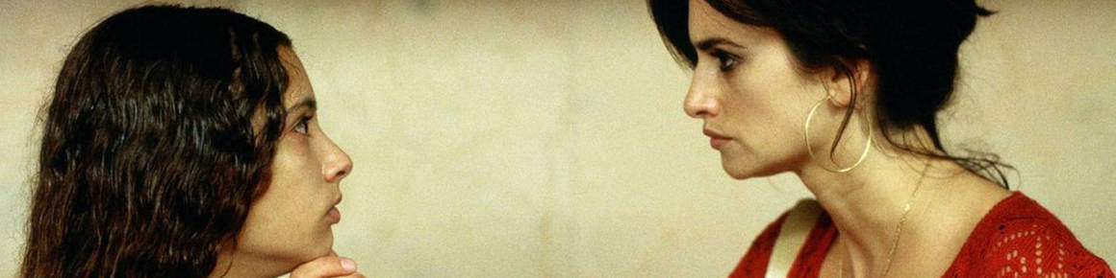
03 Sep 2019

CineMasters: Almodóvar
Spoiler warning: these notes are best read after viewing the films. They contain discussion of plot and character details for films screening in the CineMasters: Almodóvar season as well as his film, Pain and Glory.
Born in a rural town 135 miles south of Madrid, Pedro Almodóvar’s name has become synonymous with all-things-extraordinary. His distinct style, which features elements of dark comedy and just a pinch of telenovela-esque melodrama, is a product of self-education The director’s dream of studying filmmaking was never fulfilled as in 1967 Spain’s fascist dictator Francisco Franco decided to close the National School of Cinema in Madrid.[1]
The regime had a direct influence on Almodóvar’s work – his debut feature Pepi, Luci, Bom and Other Average Girls (1980) is an ode to the post-Franco era of La Movida Madrileña, the time of sexual and cultural liberation in Spain. Female friendship, colourful kitsch culture and eccentric characters of his debut still remain some of the most recognisable features of his cinema.
Women supporting each other and creating unbreakable bonds is a theme that the Spanish director revisits again and again, motherhood being one of his go-to motifs. We see it in All About My Mother (1999) as we follow Manuela, who had recently lost her son, on a journey from Madrid to Barcelona where she finds comfort in a group of women who at first glance have nothing in common; we observe an unlikely friendship develop between Marco and Benigno (Talk to Her, 2002) which intertwines the lives of Lydia and Alicia; we watch Volver’s (2006) Raimunda sacrifice herself for her daughter with unquestionable help from the local women.
The Skin I Live In (2011) seems to be an odd-one-out in this respect but only superficially – the film leaves us asking ourselves what it really means to be a man or a woman and explores Almodóvar’s fascination with the body, one’s ownership of it, and its connection to our identity. These questions had already been asked in Talk to Her and All About My Mother – before Lydia and Alicia both find themselves in a coma, disconnected from their bodies and unable to object to an unwanted touch, the two had extremely physical careers which demanded a complete control of their bodies.
The experiences of Agrado, a transwoman, constitute a statement about one’s body being just one of many elements of a person’s gender identity, which Almodóvar only reinforces by dedicating the film to “(…) men who act and become women, to all people who want to become mothers (…)”.[2] The director’s stance seems clear – gender is a performative act and at times our bodies are nothing more than the skin we are forced to live in.
Almodóvar has become known for his very particular visual style, filled with strong, intense colours, especially red, which signifies passion and emotion.[3] It heavily features in All About My Mother (with Huma Rojo’s name literally meaning ‘red’) and Talk to Her, but when it comes to Volver the director serves us a ferocious explosion of it. Red is everywhere: Soledad’s car, Raimunda’s clothes and even the gazpacho she prepares for the hungry film crew visiting the town.
In The Skin I Live In flashy colours are largely replaced by greys, blacks and whites, which makes the film somewhat stand out from the other three. However, the toned-down colour scheme of Robert’s house is not insignificant as it contributes to the feeling of being trapped and accentuates Vera’s loneliness.
And this is yet another motif that ties all four films together. It is loneliness that creeps into Manuela’s life after the death of Esteban; it is loneliness that brings Benigno so close to Alicia; it is even the name of Raimunda’s sister – Soledad. Loneliness, the need for human contact, and the idea of people’s lives being entwined with one another, are all very much present in Almodóvar’s cinema.
The director’s world is composed of a tight knit of intertextual fabric. All About My Mother clearly references All About Eve (Dir. Joseph L. Mankiewicz, 1950) whereas Talk to Her is not exactly a fairy-tale but it is possible to observe parallels between Alicia’s story and a 17th century tale that later became known as Sleeping Beauty.[4]
Referencing others is not enough for Almodóvar and revisiting his previous work could well be one of his favourite things – Talk to Her begins in the same location where All About My Mother ended. As the director says himself, ‘I wanted to start a movie in exactly the same place that I used to be before. I wanted to show that all of the success had not changed my perception.’[5] Volver, meaning ‘coming back’, invites the viewer to an Almodovarian hide-and-seek game with an abundance of self-references hiding round the corner. Most significantly, the first 30 minutes of the film are the plot of a novel written by a character from one of his previous films, The Flower of My Secret (1995).
The Spanish director also revisits his old stamping grounds of Castilla-La Mancha, comes back to the theme of motherhood and, as suggested by both himself and the plot of his newest film Pain and Glory (2019), the character of Irene could well be representative of his own mother.[6] To make things even more interesting (and reaffirm the theme of returning to one’s roots) Irene, the re-appearing mother, is played by Carmen Maura, the titular Pepi from Almodóvar’s debut. Having been cast in several of the director’s films, the two stopped speaking in lthe ate 1980s, with Women on the Verge of Nervous Breakdown (1988) being the last one they had worked on together.[7] It is worth noting that a similar re-establishment of a professional relationship with an old actor-friend features in Pain and Glory.
Almodóvar’s colourful universe, filled with melodramatic and grotesque elements makes for a cinematic scavenger hunt, oozing with surprises and peculiarities. The world has grown so accustomed to the eccentric plot twists served by the Spanish director we just won’t have it any other way.
Alicja Tokarska
Freelance translator and writer
[1] Corydon Ireland, Alvin Powell and Colleen Walsh, ‘Ten honorary degrees awarded at Commencement’, The Harvard Gazette, 04.06.2009 https://news.harvard.edu/gazette/story/2009/06/ten-honorary-degrees-awarded-at-commencement/
[2] Emphasis my own
[3] Colin Crummy, ‘Colour, Couches & Catholicism. Investigating Almodóvar’s Movies’, Amuse, 26.08.2016 https://amuse.vice.com/en_us/article/zm54gj/investigating-almodovar-movies
[4] See Giambattista Basile Sun, Moon, and Talia and Charles Perrault The Sleeping Beauty.
[5] Jose Arroyo, ‘Guardian interviews at the BFI: Pedro Almodóvar’, The Guardian, 31.07.2002 https://www.theguardian.com/film/2002/jul/31/features.pedroalmodovar
[6] Jonathan Romney, ‘Pedro’s women’, The Independent, 20.08.2006 https://www.independent.co.uk/arts-entertainment/films/features/pedros-women-6232040.html
[7] Valeria Vegas, ‘Carmen Maura y Pedro Almodóvar: Cronología de un Desencuentro’, Vanity Fair, 23.03.3018 https://www.revistavanityfair....

Pedro Almodóvar, Volver, 2006.

Norman N. Holland
Enjoying: Almodóvar doesn’t identify his characters at first, and it helps, I think, when you first see the film, to know them from the very first shot. So I’d read the first three paragraphs of the essay below.
The opening shot shows us village women cleaning the graves in a cemetery—a local custom. Almodóvar closes in on three women: Raimunda (Penélope Cruz), her teenage daughter Paula (Yohana Cobo), and Raimunda’s sister Sole or Soledad (Lola Dueñas)—her name means “alone,” and she is. These three are cleaning the grave of Raimunda and Sole’s mother and father, “burned alive” in 2002. (The film’s date is 2006.) A friend, close-cropped, gray Agustina (Blanca Portillo) passes by. A spinster, she will clean her own grave. (It is a custom in this village to buy your burial plot and tend it during your lifetime.) The point of the scene is death, and in the village the dead form part of the lives of the living.
The first three go to visit Raimunda’s and Sole’s mother’s sister, ancient Aunt Paula (Chus Lampreave in glasses for cataracts that weirdly magnify her eyes). She speaks of Raimunda and Sole’s mother as though she were alive, and Sole, when she goes upstairs, sees her mother’s picture and apparently smells something on an incongruous exercise bike. This ghost-mother is Irene (her name means “peace”). The actress playing her is Carmen Maura, one of Almodóvar’s favorites, working with him again after seventeen years of estrangement. Another “return.”
Frightened, Sole tells no one, and the three women go on to Agustina’s house across the little street—in this village, neighbors count as one of the family. Agustina tells the three she has heard Aunt Paula talking to Sole and Raimunda’s mother as though she were alive. Agustina herself longs to find her own mother who simply disappeared the same night that Raimunda and Sole’s mother and father were burned alive in a fire.
Beyond this point in the plot I’d have to use spoilers, so I’ll stop here before we meet the only important man in the film, Paco (Antonio de la Torre), Raimunda’s loutish, lecherous husband. These four women (plus one to come) are what matter.
Their visiting and loud air-kissing take place in the region of La Mancha in “the village.” (It is fictitious Alcanfor de las Infantas, camphor of the princesses—and smell plays a jokey part in this film.) This is “black Spain,” rural, conservative, backward, superstitious, and church-ridden. But Almodóvar has said, “Volver destroys all the clichés about black Spain and offers a Spain that is as real as it is the opposite. A Spain that is white, spontaneous, funny, intrepid, supportive and fair.” Well, sort of.
The opposite of black Spain is urban and sophisticated Madrid. The scenes in Raimunda’s apartment and the nearby restaurant take place here, miles from the village. The village has ghosts, religion, secrets, gossip, and the cult of the dead. The city has sickness, murder—and foreign movies on the tv. But Madrid provides the safety of anonymity. Here young Paula and Raimunda can get away with murder.
The village houses the supernatural. Madrid represents the natural world. Death in the village involves ghosts and volver—return. Death in the city is more prosaic, a frozen food locker rather than a tombstone that must be tended.
As always the opening and closing shots set the themes. In the opening shot, the camera tracks in a reverse direction from the usual. It goes from right to left—a return. The credits appear in brilliant red, and red is one of Almodóvar’s recurring images. Women dominate the scene, and the women set out what will be the mysteries to be resolved, the deaths of Raimunda’s mother and father, young Paula’s grandmother and grandfather. The opening sequence gives us the themes for the whole picture: death, women, rural life, song, red, cleaning, the return, but above all women and death.
Almodóvar deserves his reputation as a woman’s director. “Volver is as manless a movie as I have seen,” wrote reviewer Anthony Lane. Two of the men who have speaking roles disappear. One is murdered, the other goes away. Two other men appear even more briefly. One makes googly eyes at Raimunda, but nothing comes of that. The other Raimunda simply shuts out.
The opening dialogue tells us that women here—in this village—live longer than men. Women are strong and noble, while husbands are sexually insatiable lechers who molest their own daughters. There are two of them, hence a pattern of “volver—return.” The women dominate. They don’t need men, who are, with the exception of the filmmaker, the artist, worthless. But women can be artists, too. At the center of this film, as in other Almodóvar films, there is a work of art: Raimunda sings the title song. (Actually, she lip-syncs to the beautiful singing of flamenco star, Estrella Morente.) The song tells of someone returning to a first love after a long time, just what this film is about: first love is mother love.
Above all, women give life. They are mothers. They nurture and take care of others. They can be sexy like bosomy Raimunda. (I like French critic Yann Tobin’s phrasing: “ses décolletés pigeonnants.”) Incidentally, Almodóvar had Penélope Cruz fitted with some extra backside to make her look more like the lead actress of Italian neo-realism, Anna Magnani, whom we see in a brief clip on a tv. (Italian neo-realism had a big influence on Spain’s post-Franco filming.)
Alternatively, women can be not sexy but drab and gray and manless like Agustina. Either way, again and again in this film women provide food and caring. And in the final scene, we see Irene nursing and nurturing the dying Agustina. Women mother, but they also live in the presence of death, as in the opening scene. Women give life—young Paula—but they also destroy life. They murder—twice in this film. Young Paula, her mother, and her grandmother all participate in murder. And the deaths strengthen the bonds between the women who, after the men are gone and the secrets revealed, are now densely related as mother, daughter, sister, niece. This double value forms the core of Volver as in Almodóvar’s splashes of red, sometimes blood, sometimes just a lively color.
Almodóvar puts lots of red in all his movies, but in this one, he lets no chance of red go by. He gives us the opening credits in red, a red sweater, the red reel of a fire hose, a bin of tomatoes, red peppers being sliced, a red station wagon, hair dyed red, and on and on. The final shot has red-skirted Irene walking down a red-tiled, red-curtained hallway. Crucially, he has Raimunda mop up a floorful of her husband’s blood, some of it with lacy paper towels. When a caller points out that she has blood on her neck, “Women’s troubles,” she explains. As Anthony Lane quips, “She could be describing the whole film.”
Think for a moment about menstrual blood. It can mean two opposite things. It signifies the process by which new life is created. At the same time, it says that that process is not making a baby at this time. It is this duality, the creation of life and the taking away of life that permeates this whole picture from the cleaning of graves in the opening shot to the revelation that Irene did in fact burn alive her husband and his lover. This village, we are told, is famous for burned houses and a wind that fans flames, and we hear about both in connection with the murders.
Wind dominates the opening scene of women cleaning graves, and the opening line is Raimunda saying, “Put some stones in the vase. Otherwise it will fall over”—the wind will blow it over and does. The wind, like red, has a double value. On the one hand, as we hear in that opening scene, it drives people crazy. On the other, it gives power and light, as in Almodóvar’s cutaway shots of the windmills on a “wind farm.” Shades of Don Quixote—this is La Mancha, after all.
The wind adds (for me, anyway) a biblical note: “The wind bloweth where it listeth, and thou hearest the sound thereof, but canst not tell whence it cometh, and whither it goeth: so is every one that is born of the Spirit.” (Almodóvar would know the quote as the title of a famous film by Robert Bresson.) Irene is a spirit, apparently. She has hidden from Raimunda this way, in the trunk of a car, in a guest room, as “the Russian,” under a bed, or in a darkened sedan. Having her hair dyed as “the Russian,” she reinvents her identity like many another Almodóvar character.
She is the revenant, the return of the title. But there is another return, the recurring pattern in which a husband and father molests a daughter, and the wife and mother assumes the responsibility of killing him.
First thought a ghost, Irene returns in the flesh. Mother and daughter are finally reunited tearily in the house of the dying Agustina. Death again. But the last line of the film is, “Ghosts don’t cry.” In the DVD commentary, Almodóvar says. “Actually the ghost cries, which means she isn’t a ghost but has condemned herself to live like one. She makes up for what she has done, and that’s very important,” that balancing of the books to achieve a rough justice. Irene will mother Agustina, atoning. The last shot has red-skirted Irene disappearing into Agustina’s house. There is a death in the house but also a rebirth, a return, volver.
The final credits use the patterns from various fabrics (i.e., weavings) associated with Raimunda that have appeared in the movie, the skirt she was wearing when she cleaned the grave, the skirt she was wearing when she met her daughter at the bus stop, the red-checked blouse she wears when she sings, flowers, trees, thorns—all emblems of femininity as Almodóvar conceives it.
“This is a movie about mothers,” Almodóvar says in his commentary. Mother-love is Almodóvar’s constant theme, not just in this movie. But, as the psychoanalysts tell us, babies not only love mother because she feeds them, but babies also hate her when she doesn’t. (Those furious screams of frustration.) We as adults, all of us, are ambivalent toward mothers, and mothers are toward us. Volver nicely captures that psychological truth in its double-barreled portrayal of mothers (and daughters) as both giving life and taking life. And it is so artfully done we scarcely notice that, underneath the satisfying mystery movie, lies a disturbing truth. Almodóvar shows once again how subtle and powerful an artist he is.
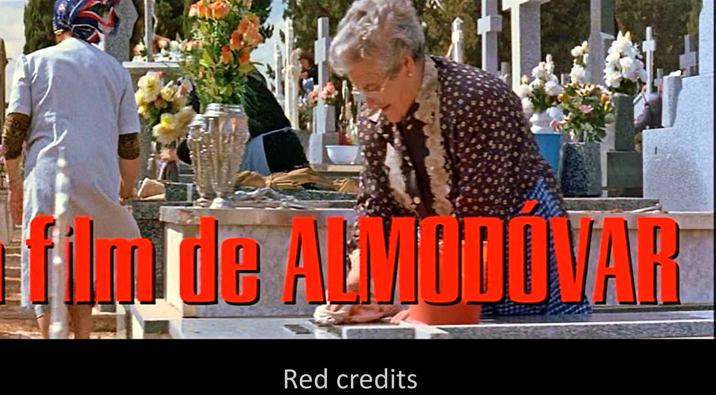
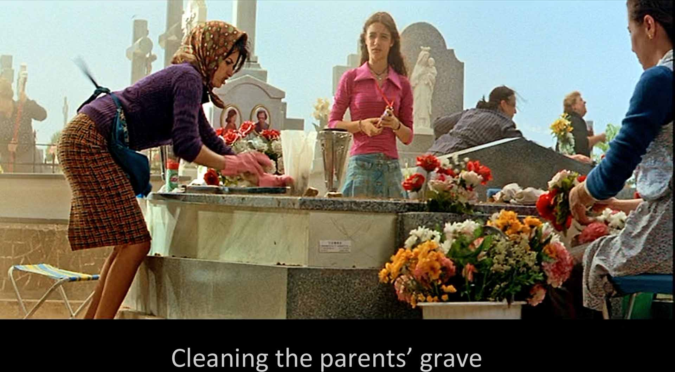
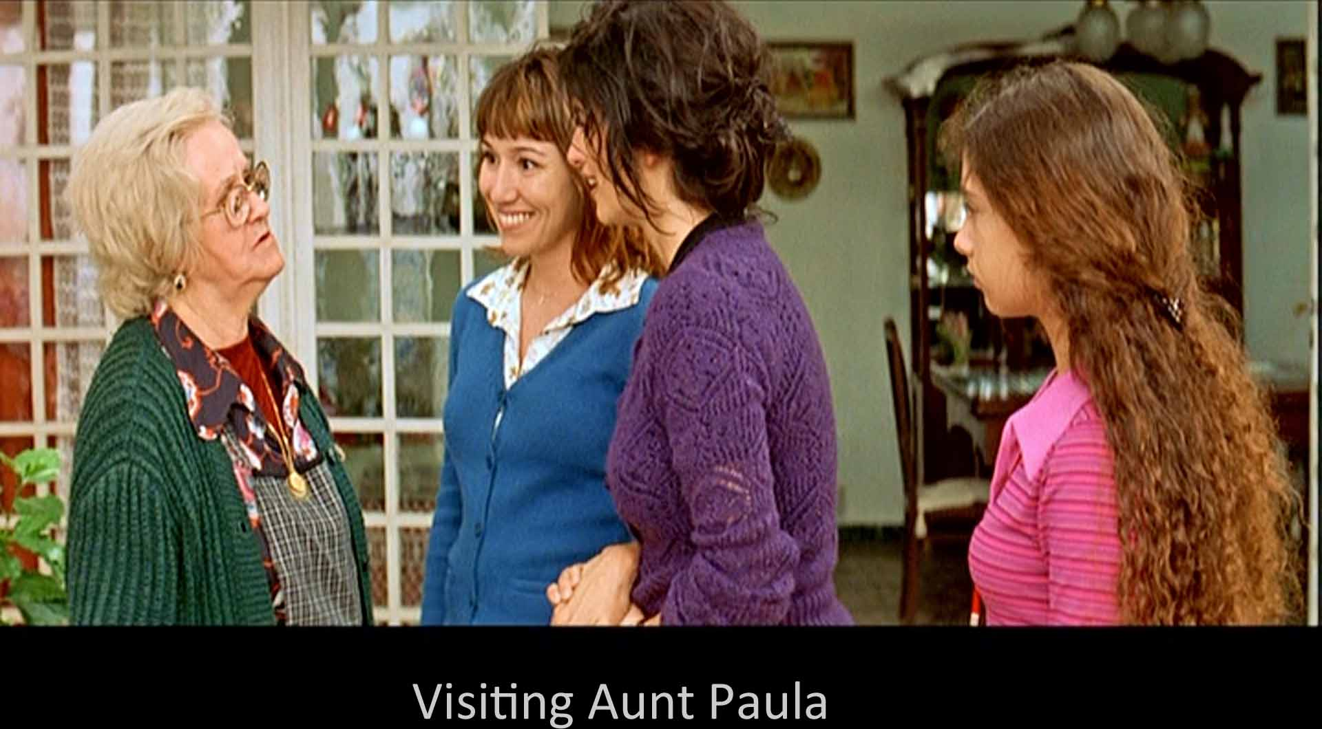
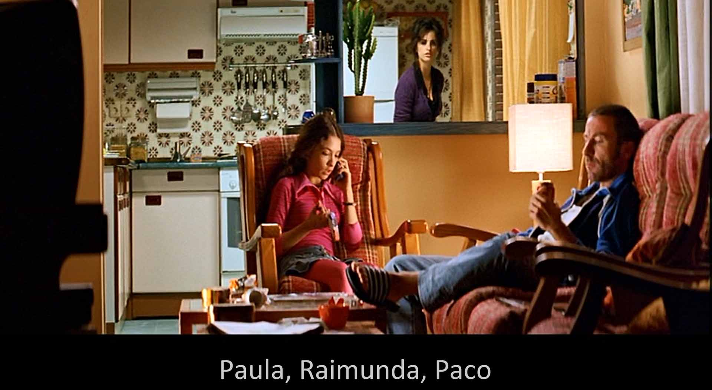
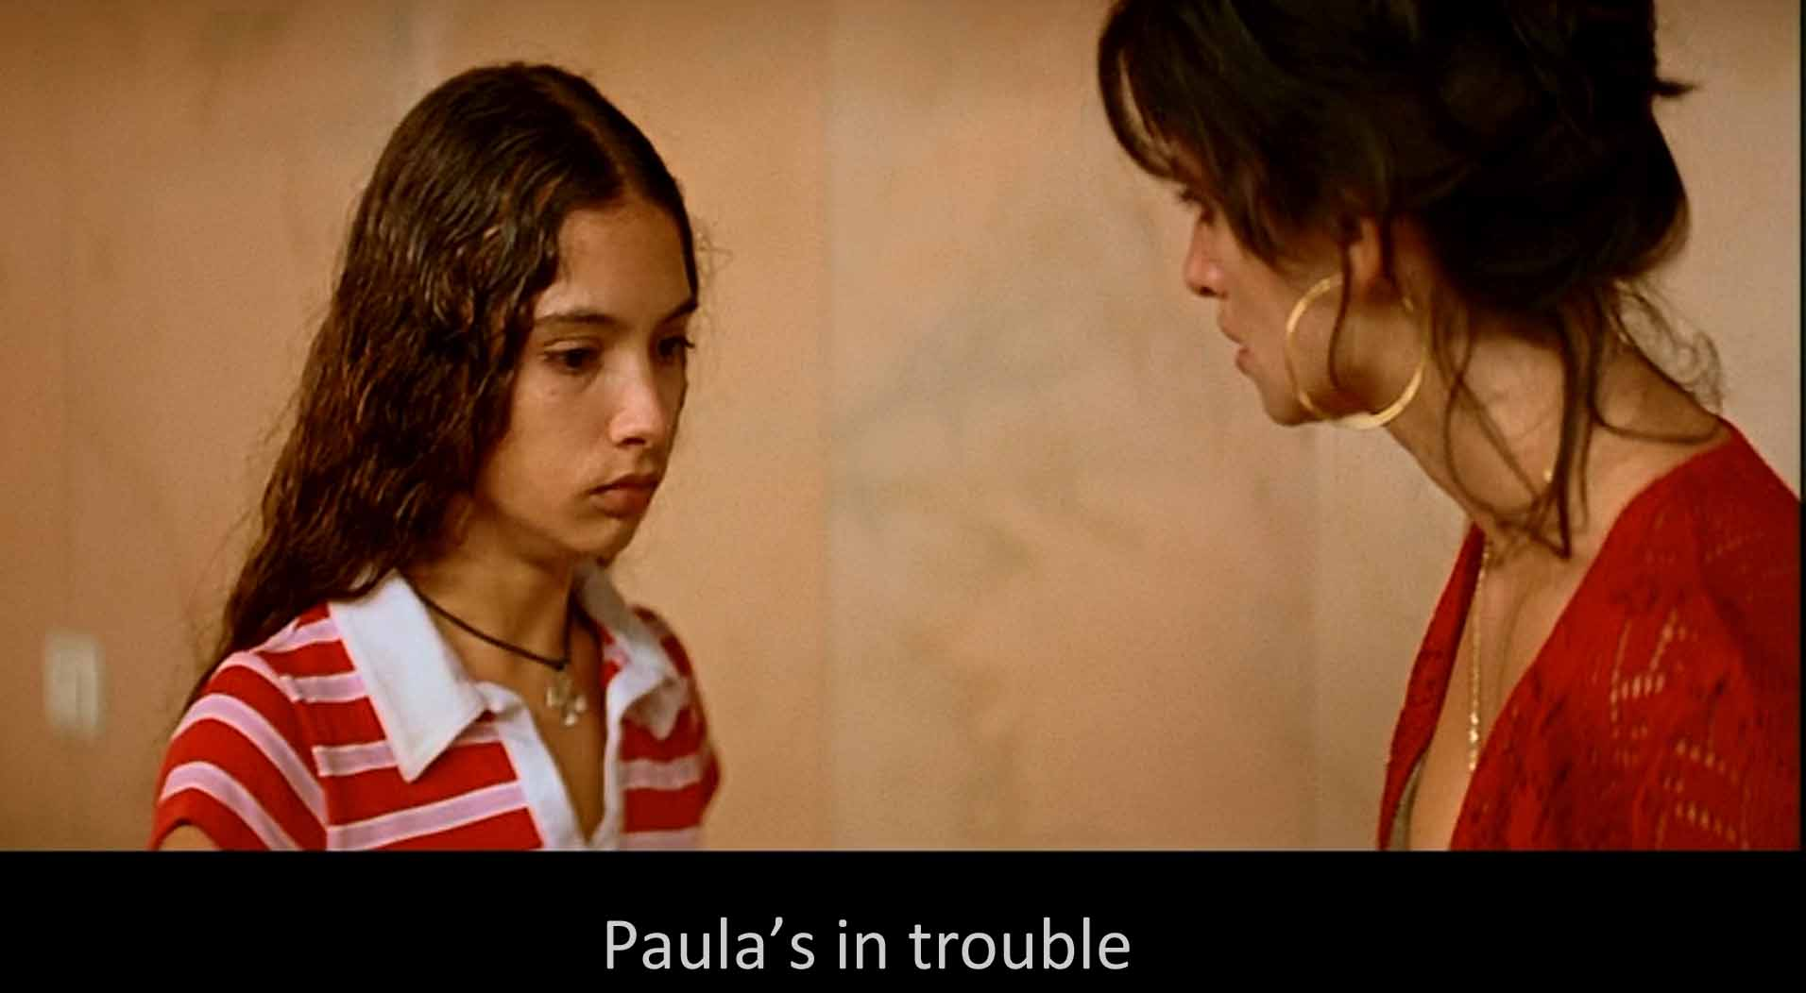
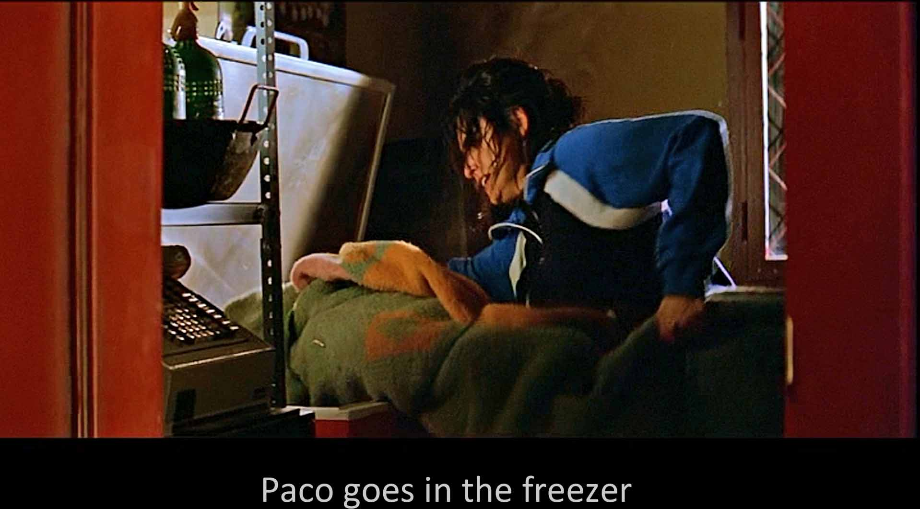
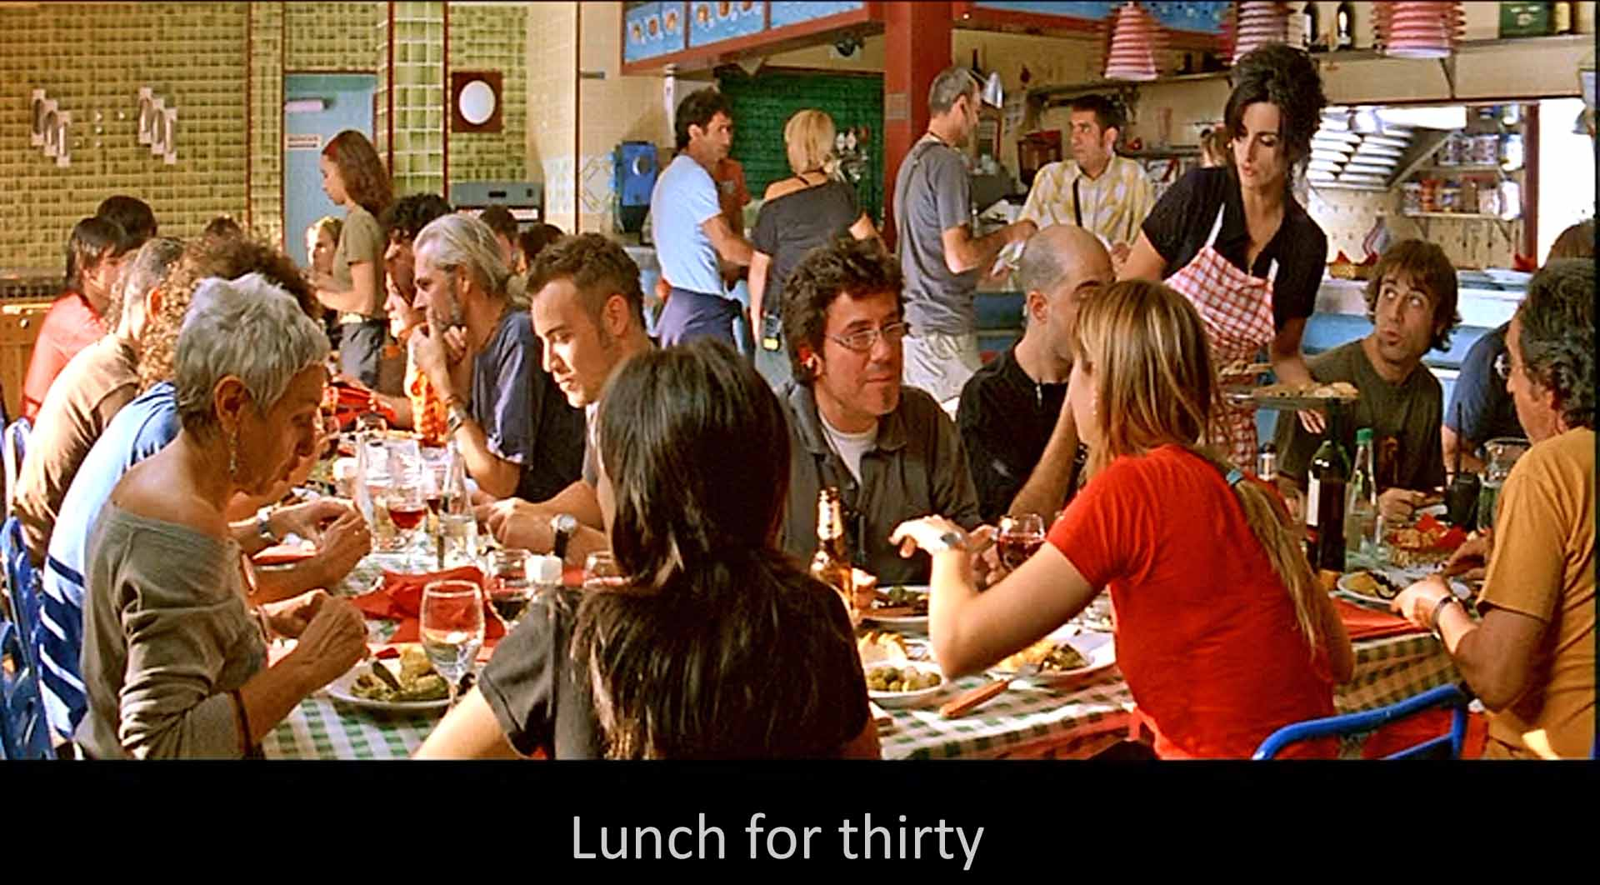
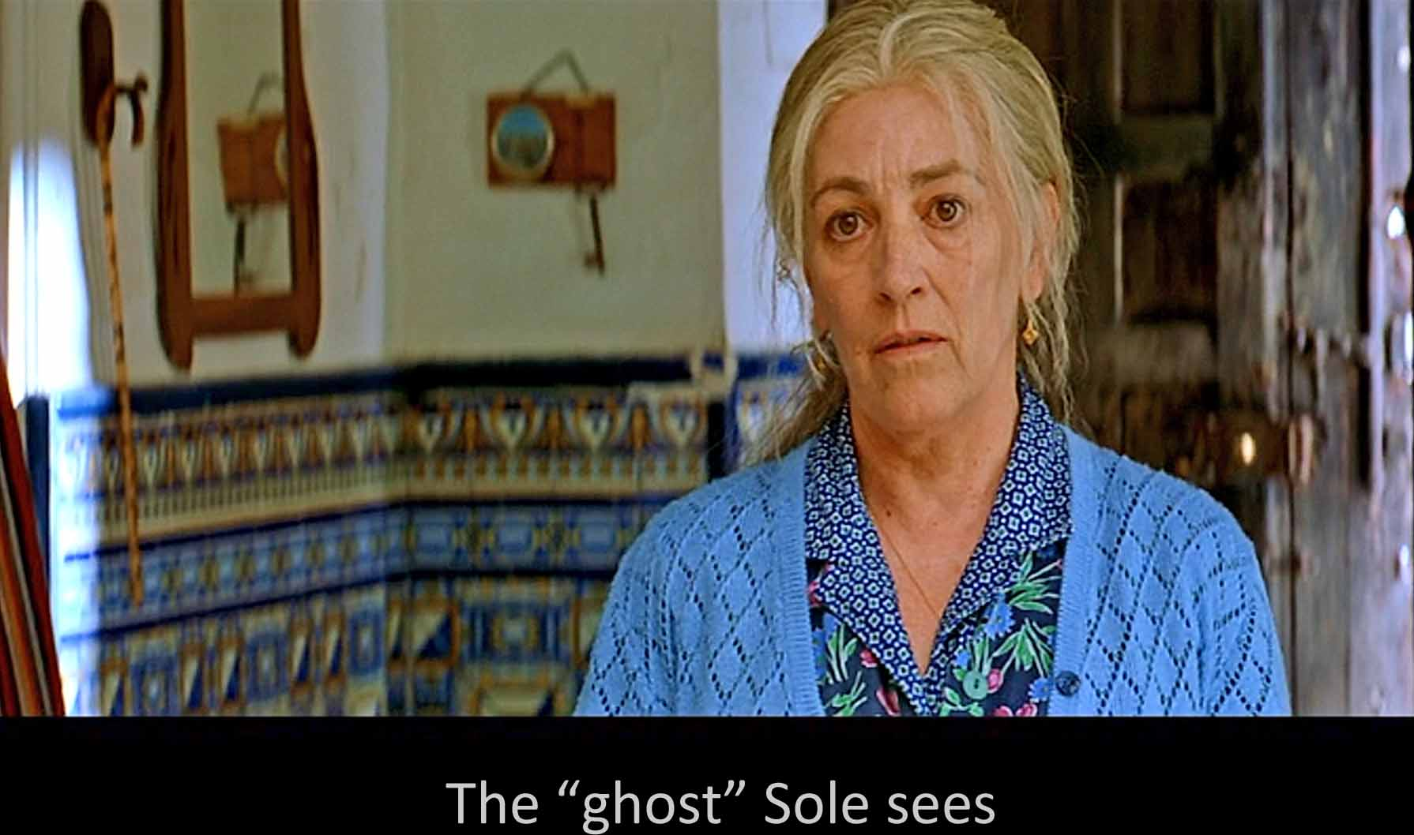
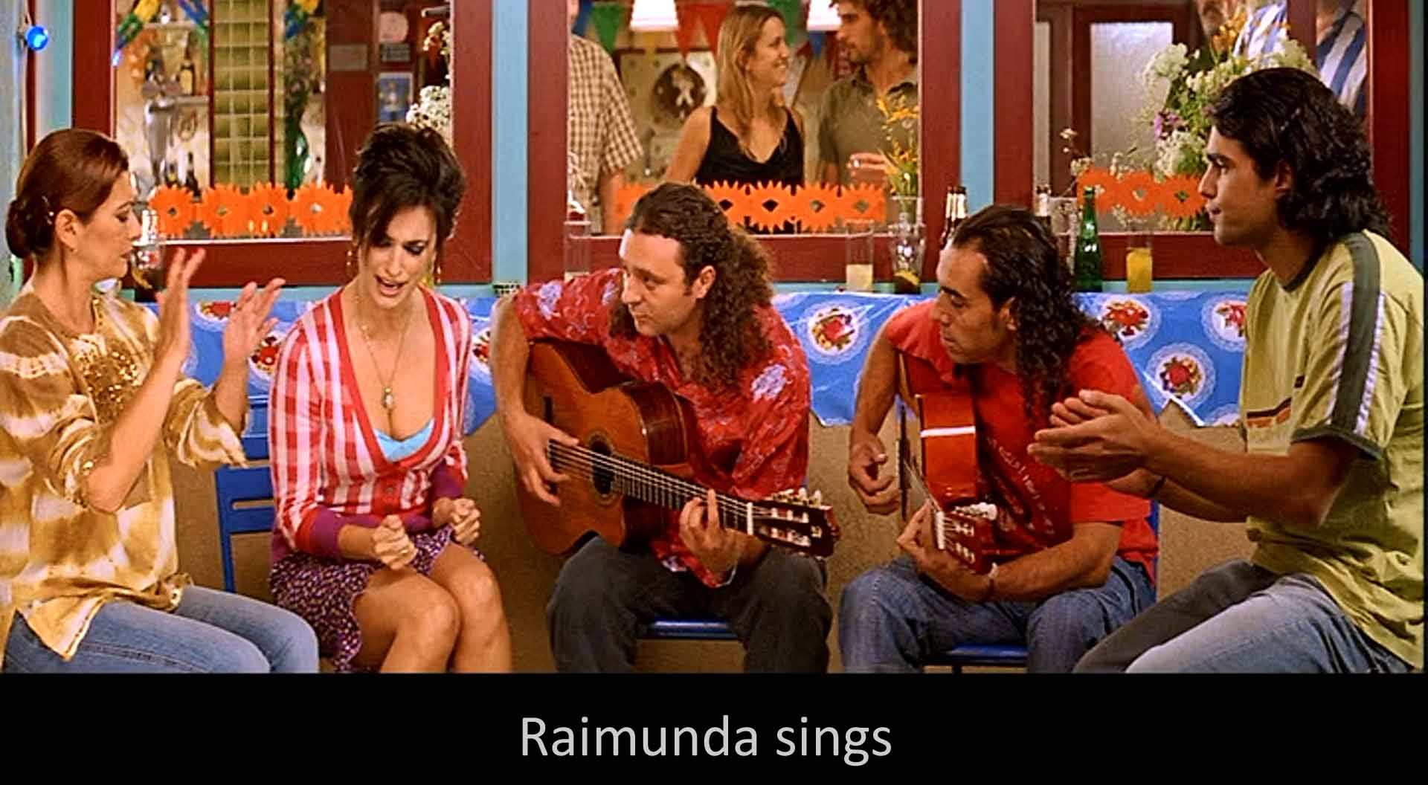
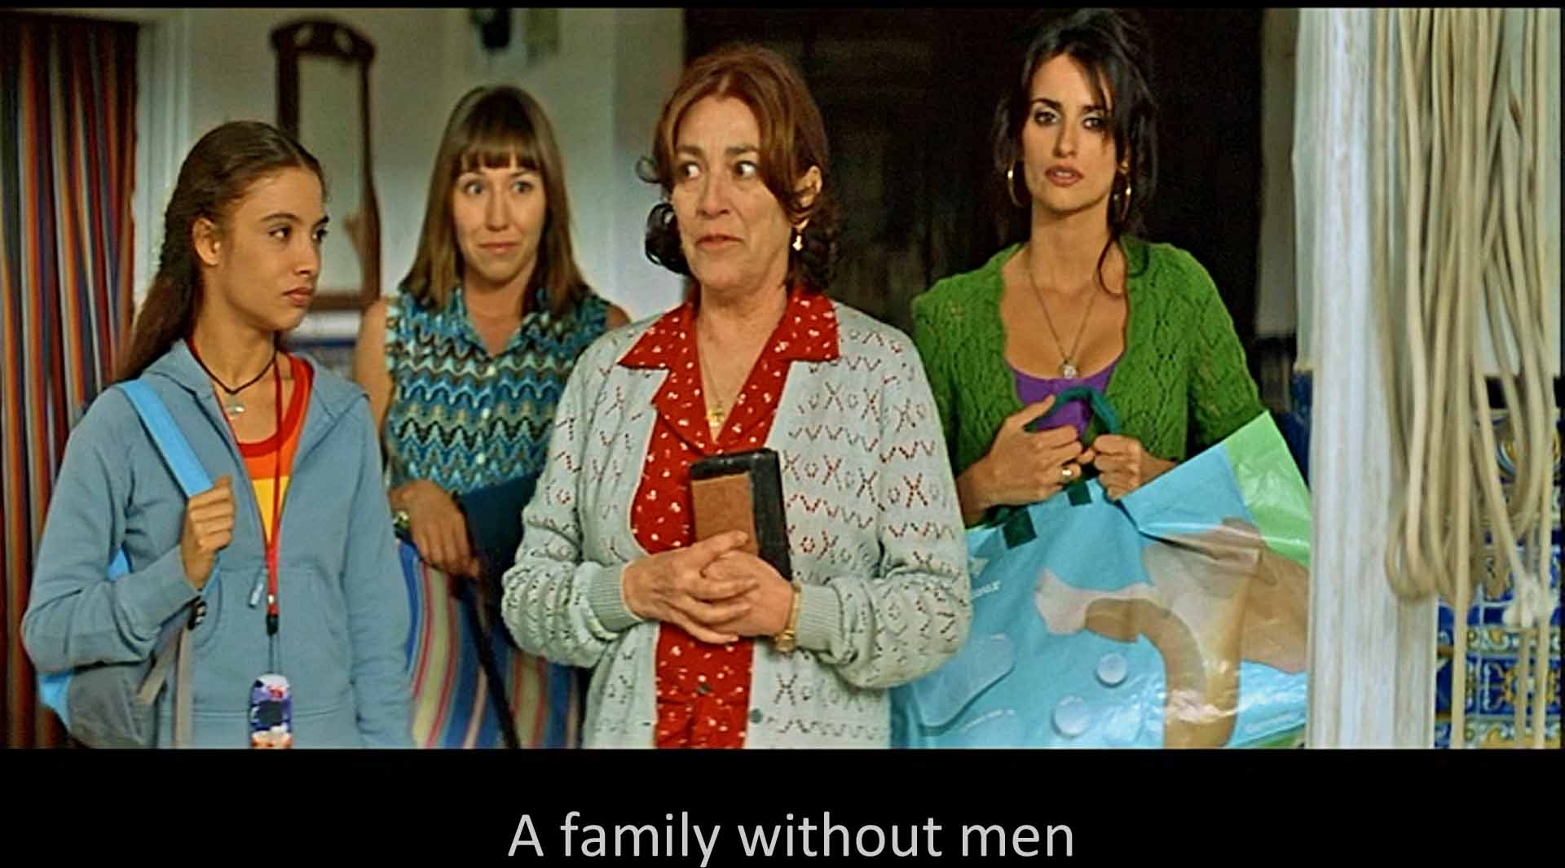
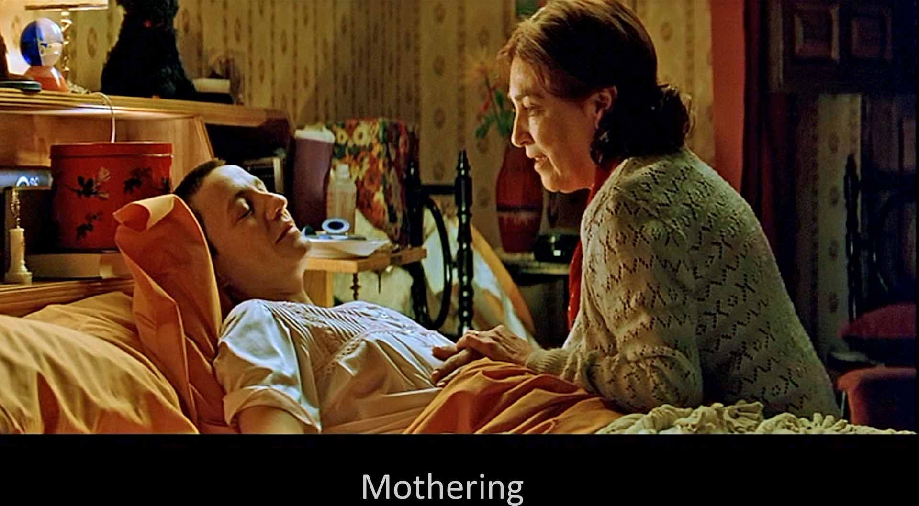
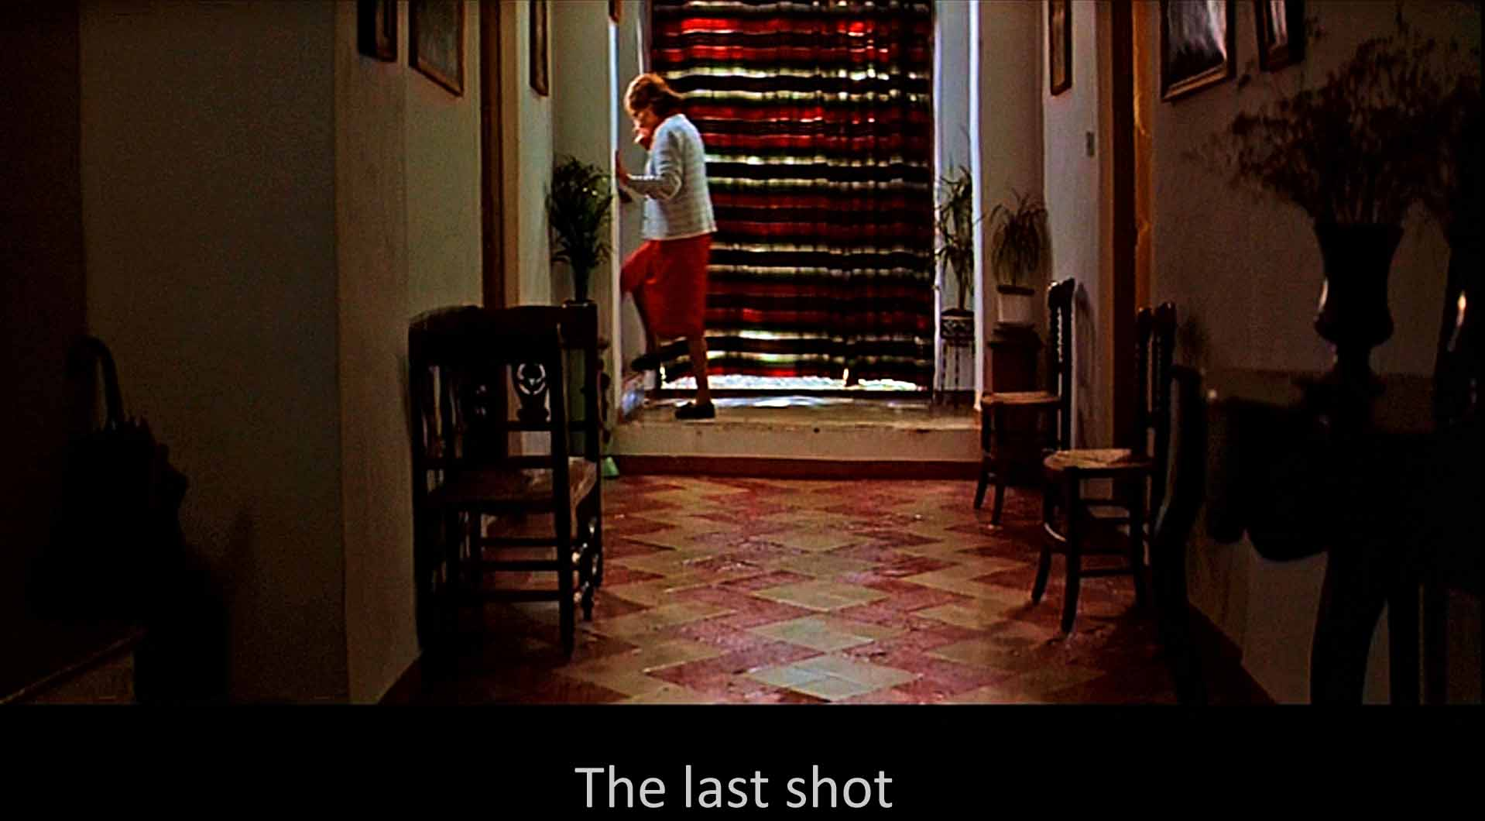
Items I’ve quoted from:
Almodóvar, Pedro. “Confession,” Volver Press Notes (Sony Pictures Classics, 2006). http://www.emanuellevy.com/interview/volver-almodovars-confession-9. Accessed January 21, 2013.
Lane, Anthony. “The Current Cinema: In Your Face.” The New Yorker (Nov 6, 2006): 106-107, 109.
Tobin, Yann. “Volver - Les femmes de la Mancha.” Positif - Revue mensuelle de cinéma (May 2006): 15-16.
Enjoying: See it again and watch for details whose presence seems a little odd in the movie. Ask yourself what they are doing there. You’ll appreciate his artistry all the more. Why a freezer? Why a film crew instead of, say, a construction gang? Why Aunt Paula's grotesque glasses? Remember that Almodóvar writes his own screenplays as well as choosing what will appear onscreen. Everything is chosen. If you're curious about my answers to such questions, look at the source code for this paragraph (usually, click on View, then Source Code or Code).

Volver – review
5 / 5 stars5 out of 5 stars.

Cert 15
A gripping melodrama inspired by the trash TV that is a soundtrack to its characters’ lives.
Peter Bradshaw
@PeterBradshaw1
Fri 25 Aug 2006 00.02 BSTFirst published on Fri 25 Aug 2006 00.02 BST

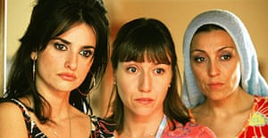
Gripping melodrama ... Pedro Almodovar’s Volver
With its overwhelming richness, its colour and warmth, Pedro Almodóvar's new movie is set to capture your heart. Volver seemed guilelessly wonderful when I first saw it earlier this year in Cannes. Now it looks even better. The picture's ingenuities and contrivances just seem to float out of the screen, like psychedelic moodshapes. I found myself floating right along with them.
His last two films, Bad Education and Talk To Her, were impressive, though I never quite felt the unconditional rapture of the true Almodóvar believer. This new film, being more modest in its scope, and somehow less obviously extravagant, achieves more with its rhetorical flourishes and narrative display. There is something so playful and gorgeous about it, and certainly something gorgeous about Penélope Cruz: although the film is notable in that romantic love is quite irrelevant. Cruz's beauty appears in an altogether different love-context: that of a mother's passionate love for her daughter.
Advertisement
Volver, (in English, Coming Home or Coming Back), is a gripping melodrama inspired by the trash TV that is a soundtrack to its characters' lives. Penélope Cruz is Raimunda, a hard-working woman with a teenage daughter, Paula (Yohana Cobo), and a feckless, layabout husband. With her sister Sole (Lola Dueñas) she tends to the graves of her parents, and visits her ailing Aunt Paula (Chus Lampreave), who is heartrendingly in the final stages of dementia. Raimunda's family life shatters with one terrible act of violence, and there is a secret about her late mother Irene (Carmen Maura) that surfaces when Irene returns from beyond the grave to make contact with her astonished daughters.
So Volver is a ghost story. Or is it? As the movie drifts along the periphery of the supernatural, I went into a trance, which Almodóvar induces with a master's confidence. All the movie's secrets are rolled out in a narrative design that is exuberant and elegant. Its cinematography and art direction, by José Luis Alcaine and Salvador Parra, give everything an intensity that, like previous Almodóvar films, has the feel of a Douglas Sirk film. Almodóvar has something of Sirk's passionate empathy with women, mixed with a gay sensibility - though the film is unlike Sirk's in that men are entirely marginal. In its vividness and intense, almost neurotic sensitivity to colour, particularly the colour red, it also looks like a Hitchcock thriller.
There is a wonderful overhead shot of Raimunda washing up a bloodstained knife in the kitchen sink. On the left of the screen, we see the implement of violence in the plastic bowl above the soiled plates, and on the right there is the glistening crown of Raimunda's glorious raven hair and her magnificent cleavage - the size of which her mother is later wonderingly to remark upon, and in which nestles an enamel miniature of the crucified Christ. The image goes beyond camp, and certainly beyond desire, into a feminised world in which work, survival and family love are paramount. A neighbour asks about the bloodstain on her neck, and quick-thinking Raimunda says it is merely "women's trouble": a laugh line that relieves the tension, but is also nothing more nor less than the truth.
When Cruz struts with unselfconscious sexiness through the streets, carrying a rounded, wiggling behind that might almost be prosthetic, she resembles the young Sophia Loren. She moves, however, without the soundtrack of wolf-whistles that earlier ages might have composed for her. There are a couple of men in the picture who are in love with Raimunda, but they are tentative and almost reticent in their adoration.
Her real relationship is with her daughter, her sister, her mother and with her garrulous women-friends and neighbours - all chattering, laughing and, at a funeral, mumbling prayers like a swarm of pious, black-clad bees. But of course, Cruz is intensely engaged with one man: Almodóvar himself, who manages to draw out her presence like a ductile material and spread it all over his movie. Only Cruz could have carried off those hoop earrings, as big as soup-plates, and on anyone else her black top with the flowery design might have looked as if it came from Primark. On her it looks sensational, and its floral motif is carried over into the final credit sequence.
It is this context of beauty, richly sensual without being sexual, that makes the gestures of tragicomedy and passion so affecting. When Raimunda says to her miraculously returned mother: "I don't know how I have lived all these years without you ..." it is absurd, and comic, but also intensely poignant. And as often in the past, Almodóvar makes a song a central moment in the film. Raimunda has abandoned her dreary day jobs to take over an absent friend's restaurant and cater for a visiting movie crew. Here, she impulsively decides to sing to the assembled company a showstopping lament about the return of past lives and loves - an irresistibly generous and emotional event.
No other director has as much swoon factor as Pedro Almodóvar: the texture of his movie-making is quite unique. Volver could have gone on for another hour or two: there seemed so much more to say. What a triumph for this great European director who just seems to get better and better.

APPENDIX 3 – Equal Rights activities
1a. Lee el obituario de Mera Goyenechea y empareja las palabras (1–6) con su equivalente (a–f) en inglés.
- hadas a. housework
- costurera b. disabled
- bata c. outraged
- los quehaceres d. housecoat
- discapacitados e. seamstress
- indignados f. fairy

Mera Goyenechea: 28 de enero 1944 – 15 de agosto 2013
Costurera que fundó Zara y llegó a ser la mujer “self-made” más rica del mundo
Como si todo fuera un cuento de hadas, Rosalía Mera dejó el colegio a los once años para trabajar como costurera en La Maja, un almacén de ropa en su ciudad natal, sin saber que llegaría a convertirse en una de las mujeres y empresarias más reconocidas de España.
Fue en este almacén de A Coruña donde conoció a Amancio Ortega, que trabajaba como mensajero en el mismo lugar. Todo comenzó durante los años de la posguerra cuando había mucha pobreza, por eso, en 1963 decidieron establecer su propio negocio, GOA, fabricando batas y levantadoras bien coloridas – prendas típicas que llevaban las mujeres españolas mientras hacían los quehaceres.
Unos años más tarde se casaron y en 1985 fundaron el grupo de textiles Inditex cuyo prestigioso almacén Zara tiene hoy en día una fama mundial. Mientras tanto, Mera había tomado la decisión de regresar al colegio y en 1973 se graduó como profesora de primaria. Más tarde siguió estudiando psicología.
A pesar del éxito del grupo, el matrimonio no perduró y se divorciaron en 1986. Rosalía Mera continuó afiliada al grupo, sirviendo como miembro de la junta directiva de la empresa, pero siguiendo su propio camino. En 1986 lanzó la Fundación Paideia Galiza, una entidad caritativa para niños con discapacidades físicas y mentales que también apoyaba muchas iniciativas para ayudar a mujeres. Fue una voz no solo feminista sino también filantrópica y progresista. Apoyó al movimiento de los indignados protestando contra la austeridad y la corrupción en 2011. Siempre mostró ser una mujer dinámica, inteligente pero sencilla.

1b. Contesta las preguntas.
- ¿De qué trata el artículo?
______________________________________________________________________________
______________________________________________________________________________
- ¿Qué importancia tiene Rosalía Mera?
______________________________________________________________________________
______________________________________________________________________________

- ¿Cuándo comenzó su cuento de hadas?
______________________________________________________________________________
______________________________________________________________________________
- ¿Cómo se describe el período en el que transcurrió su vida?
______________________________________________________________________________
______________________________________________________________________________
- ¿Por qué crees que el año 1973 fue significativo?
______________________________________________________________________________
______________________________________________________________________________
- ¿A quiénes ayudaba con su Fundación?
______________________________________________________________________________
______________________________________________________________________________

1c. Lee el texto otra vez y escribe un resumen usando un máximo de 70 palabras. Hay 5 puntos extra por la calidad del español. Incluye:
- la razón / el pretexto del artículo
- el comienzo de su vida
- las decisiones importantes que tomó
- su actitud hacia la vida
_________________________________________________________________________________
_________________________________________________________________________________
_________________________________________________________________________________
_________________________________________________________________________________
_________________________________________________________________________________
_________________________________________________________________________________
_________________________________________________________________________________
_________________________________________________________________________________
_________________________________________________________________________________
_________________________________________________________________________________
_________________________________________________________________________________
_________________________________________________________________________________
_________________________________________________________________________________

1d. Traduce el último párrafo al inglés.
_________________________________________________________________________________
_________________________________________________________________________________
_________________________________________________________________________________
_________________________________________________________________________________
_________________________________________________________________________________
_________________________________________________________________________________
_________________________________________________________________________________
_________________________________________________________________________________
_________________________________________________________________________________
_________________________________________________________________________________
_________________________________________________________________________________
_________________________________________________________________________________
_________________________________________________________________________________
_________________________________________________________________________________
_________________________________________________________________________________
_________________________________________________________________________________
_________________________________________________________________________________

2. Busca en Internet información sobre una de estas personas famosas. Toma notas y luego escribe un artículo de unas 70 palabras siguiendo el ejemplo en la actividad 1a.
- La Duquesa de Alba
- La Pasionaria
- Rigoberta Menchú Tum
- Evita Perón
_________________________________________________________________________________
_________________________________________________________________________________
_________________________________________________________________________________
_________________________________________________________________________________
_________________________________________________________________________________
_________________________________________________________________________________
_________________________________________________________________________________
_________________________________________________________________________________
_________________________________________________________________________________
_________________________________________________________________________________
_________________________________________________________________________________

